Yr Group | Topic 1 | Topic 2 | Topic 3 | Topic 4 | Topic 5 | Topic 6
EYFS  Driver project | Let's Explore  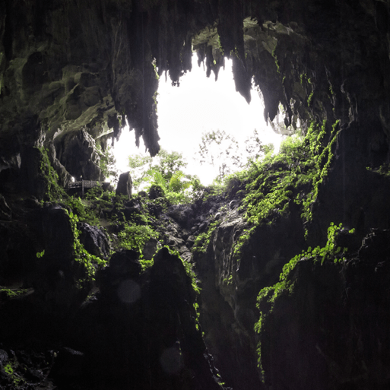  In this project the children will draw the human form from observation.  They are introduced to painting techniques and paint from memory. | Marvellous Machines  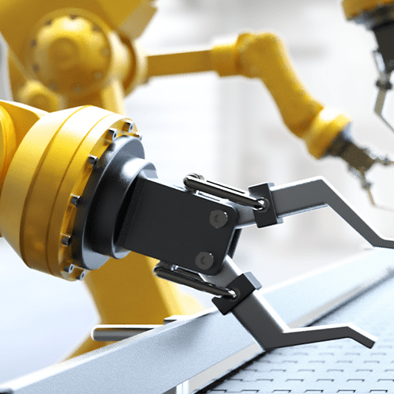  In this project the children will use paint programs to create artwork and explore 2D & 3D objects in digital art. They will develop drawing skills to look closely. They are introduced to simple block print making to create art work | Long Ago  In this project the children will develop drawing lines, spirals and simple 2D shapes.they explore colour mixing to create tints and tones adding white / black to coloured paint.  They use K& U human form to develop drawing/ painting portraits skills.They look at the work of significant portrait artists Van Gogh and Rembrandt.  They will explore clay properties by rolling /shaping and marking. | Ready Steady Grow  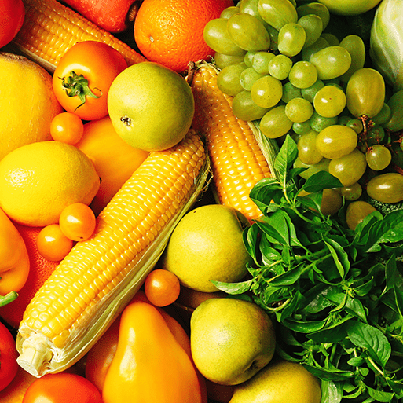  In this project the children will explore transitional art using natural material to make patterns & images .They will develop printing skills using natural objects and further develop colour mixing skills. | Animal Safari  Companion 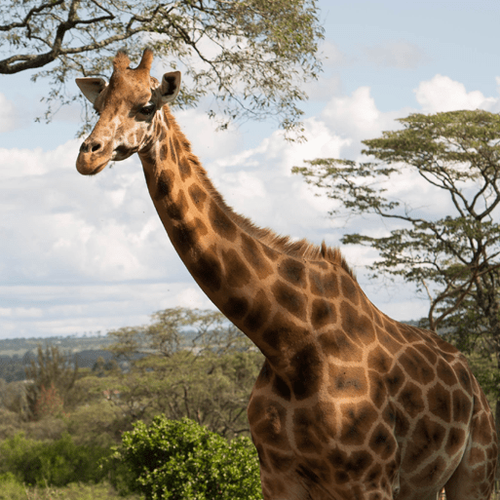  In this project the children will create art work on theme of animals In this project the children making observational animal drawings. They will revisit printing to create animal inspired prints | On the Beach  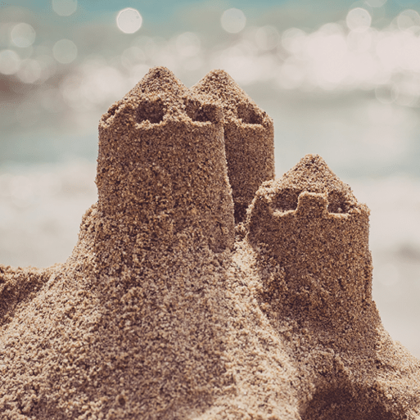  In this project the children will ,create art work based on images of the sea. They will explore the work of the artist Henri Matisse and develop scissor skills to create collages
EYFS  Mini Project | Build it  Up  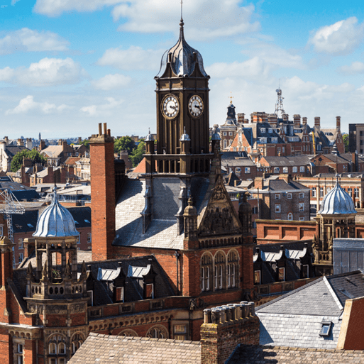  In this mini project the children will develop printing skills , they will print brick patterns, buildings and features from observation and imagination. | Puppets and Pop ups  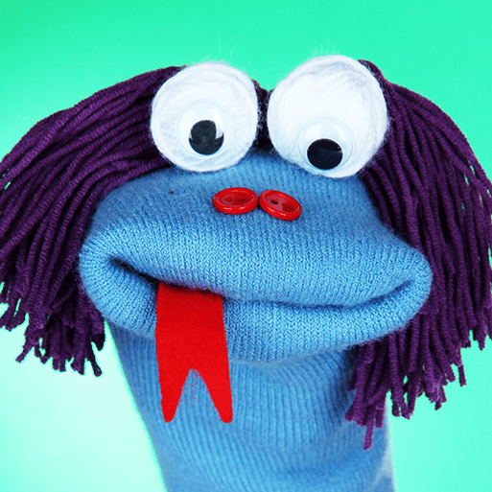  In this mini project the children are introduced to simple threading and sewing to create fabric swatch art work. | Stories and  Rhymes  .  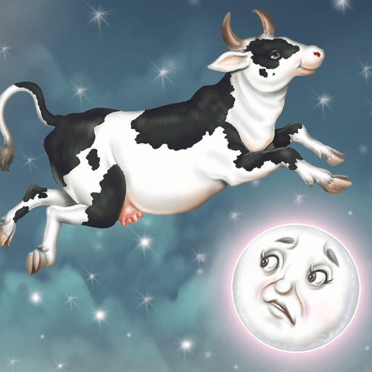  In this mini project the children will.develop their understanding of colour mixing and using the 3 primary colours. | Signs of  Spring  I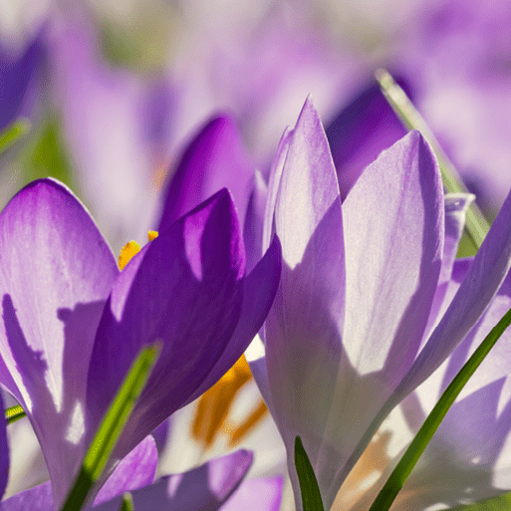  In this mini project the children will .discuss their art work and describe the tools and techniques used. | Creep, Crawl, Wriggle  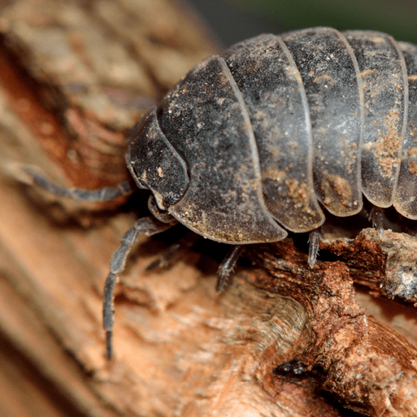  In this mini project the children will.develop knowledge of significant artists introduced in Long Ago project and eplore Matisse’s The Snail. They will make clay models. | Moving on  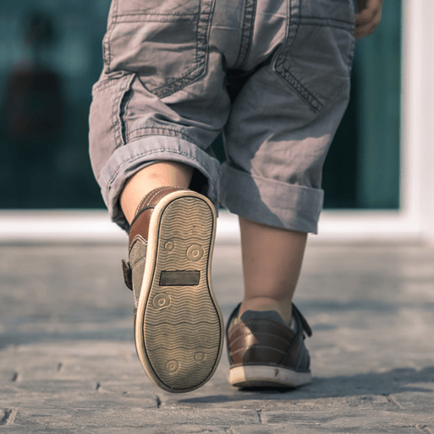  In this mini project for transition the children apply drawing and painting skills to create self portraits.
KS1  LKS2 | l  Mix it  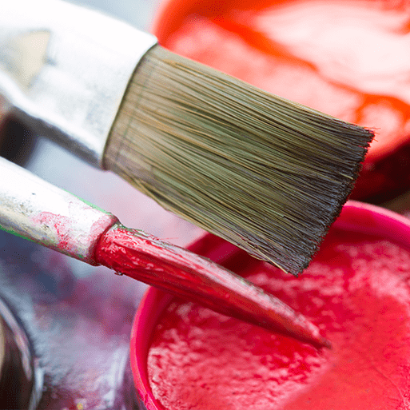  In this project the children are introduced to colour theory ,revisiting the names of the primary colours and mixing secondary colours, whilst exploring ways to create hues of colours.They explore & describe the use of colour in various paintings from different artists & genre susing colour related vocabulary. They paint simple colour wheels and use the primary / secondary colours to create own artwork piece. |  |  |  | Flower heads  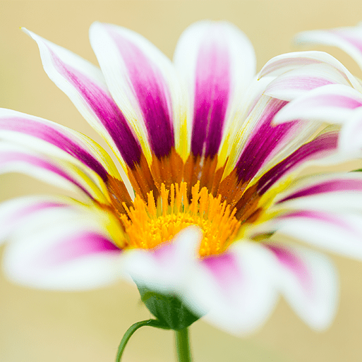  In this project children build on use of sculptural form and develop observational drawing / painting skills to study floral art from different artists and genres focussing on how artists use visual elements to create interest. They will explore properties of shape/ form/texture/ pattern and colour to make 3D artwork.  They will study the work of Japanese artist Yayoi Kusama & her giant flower sculptures & use clay / paper to create own artwork in her style. |  |  |  |  |  | Portraits and poses  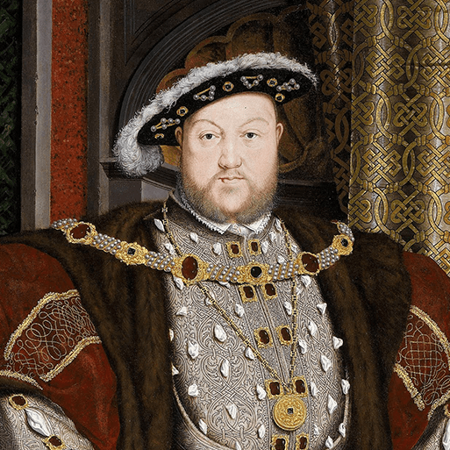  In this project children will revisit portraiture and be introduced to Tudor portraits to study their style and symbolic importance  They will make simple sketches of each other holding poses and use software to create simple line drawings. They will also learn about digital portraiture and use I Pads to photo each other and edit using software to create regal portraits. |  | Still life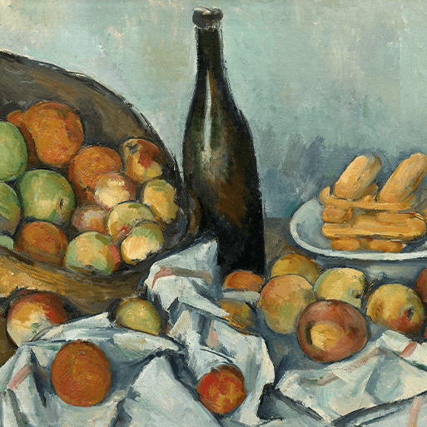  The children are introduced to the term ‘still life ’making thumbnail sketches of famous still life art works & discuss subject, colour, composition and texture. They will look at still life art from significant artists Van Gogh, Cezanne and Georges Braque  The children will explore colour in more depth mixing & making colours to match a section of a painting, they use their learning to organise a still life and paint it. They will practise drawing outlines and 1st hand observations.  They will explore making forms with texture from clay.
 | Contrast and complement  Children are extending their understanding of colour theory ,learning about colour families including complementary and tertiary colours. Children are introduced to watercolour paint ,revisiting the colour wheel to record each colour family. They will analyse a favourite painting to mix its colours accurately to create own imaginative colour composition. |  | Warp and weft  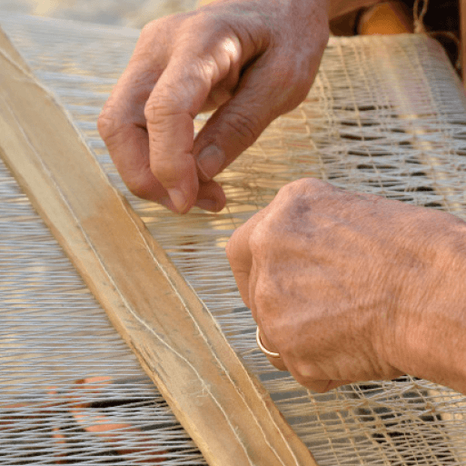  Children will visit loom weaving exploring weaving through time and learn about properties of yarns- texture ,colour ,and type .They will sort yarns into warm/ cool colour groups and record in sketch books. They will design & make mini loom weave wall hanging. |  | Vista  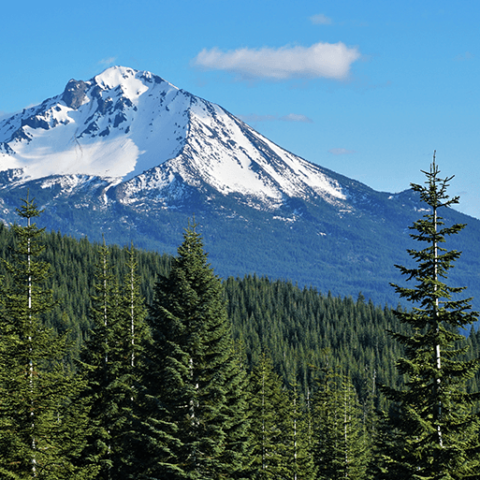  Children will study, explore & discuss examples of famous landscape paintings, learn how to use a view finder and work outdoors to find interesting perspectives to sketch .Children will be introduced to atmospheric perspective and will explore this technique in sketch books in pen, ink and pencil, .they will use knowledge of warm & cool colours to compare use of colour in landscape art.  They will produce their own landscape picture using a photo as a starting point. |  |  | Animal  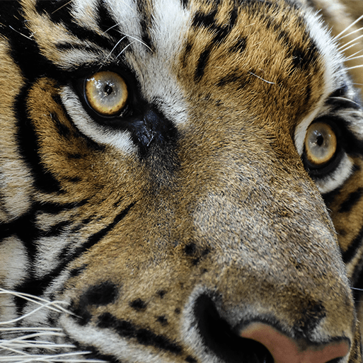  Using nature as the starting point they will look at how significant artists have been inspired by animals to create various artwork including sculptures from different cultures and time. Children will be introduced to drawing different animal forms studying pattern, colour, and texture. They will use clay to make a 3D model in the style of a Bankura horse. |  |  | Statues statuettes & figurines 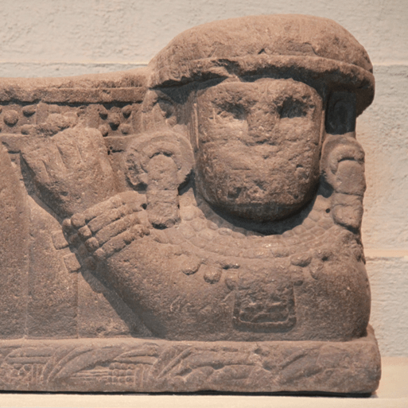  Children will explore figurative art in 3D looking at the representation of the human form in sculpture studying examples from Ancient Egypt & ancient Sumer.  The children develop clay sculpting skills to create a Sumer style figurine. |  | Islamic Art  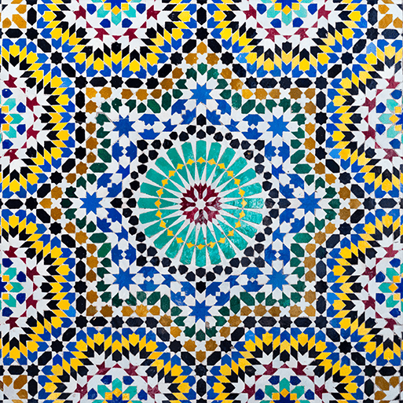  Children will develop motif art exploring geometric shapes in Islamic art and how to use them to create simple & complex motifs. They will explore circles as a basis for patterns using a traditional pencil & compass technique. They will explore the use of grids to create repeat patterns. They will use clay skills to create relief sculpture with geometric motifs.
 | Tints,Tones and Shades  Children revisit their understanding of colour theory introducing the terms tints, tone and shade and learn how to mix them with systematic accuracy.They will study how artists use tints ,tones and shade in landscapes paintings and explore how they can be used to represent light ,shadow and perspective. |  | Trailblazers, barrier breakers  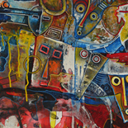  Children will explore the barrier breaking black artists, researching art pieces of a favourite artist then create and present a digital mood board about their work and its significance .Children explore how artists portray narrative & meaning in their artwork. They will use sketch books to develop their ideas on human rights, equality and race in the studied art work . |  | Bees, ,Beetles & Butterflies  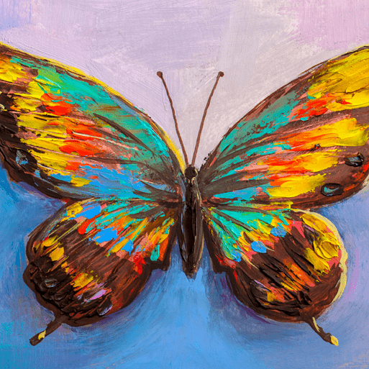  Children revisit nature theme and explore and make observational drawings of insects & mixed media collages. They learn about the significant artist Andy Warhol printmaker and use what they learn to create Pop art bees.They will produce artwork inspired by bees, beetles or butterflies. |  |  | Inuit 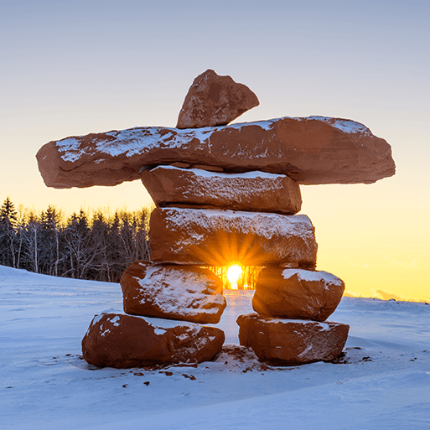  Children will learn about the art , craft and culture of the Inuits.They will revisit the theme of animals and will study the art of Jessie Oonark,Karoo Ashevak and other significant Inuit artists. Children will create detailed drawings of traditional carvings and carve simple lines and animal shapes into soap blocks. They will be introduced to stencil making to create a series of prints in chosen colour combinations. |  |  | Environmental Artists  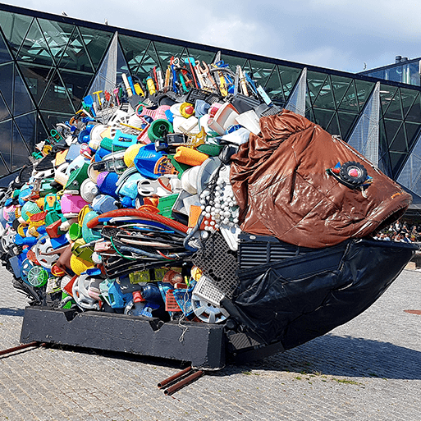  The children are introduced to the genre of environmental art and study ways various artists have addressed environmental issues through their artwork. They will collect and explore recycled materials to create own artwork with a environmental message. They will use digital technology and editing software to create digital art. |  | Distortion and Abstraction  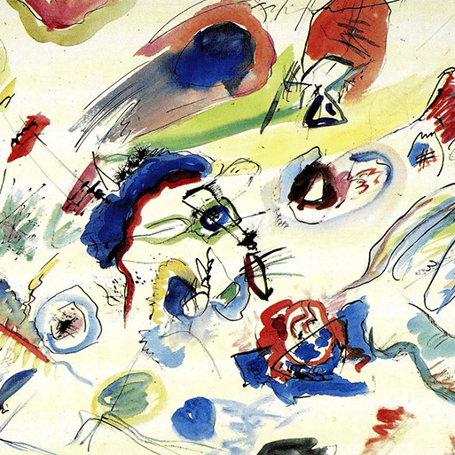  Children will explore concepts of abstraction and distortion. They will learn about the abstract movement in Cubism and Orphism.They will study visual characteristics of abstraction including line, shape and colour. They will use their knowledge to create own musically inspired abstract painting.

