Yr Group | Topic 1 |  | Topic 2 |  | Topic 3 |  |  | Topic 4 |  |  | Topic 5 |  | Topic 6
EYFS  Driver project | Let's Explore  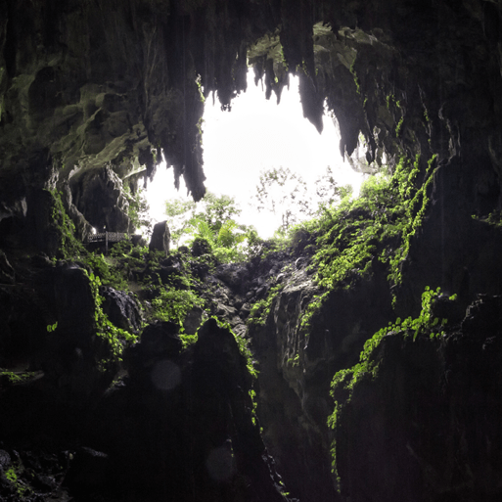 |  | Marvellous Machines  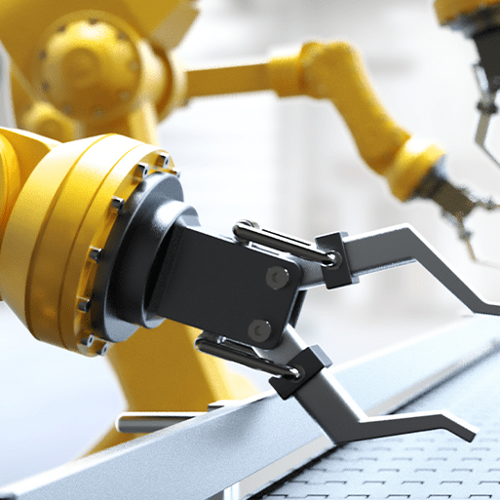 |  | Long Ago |  |  | Ready Steady Grow  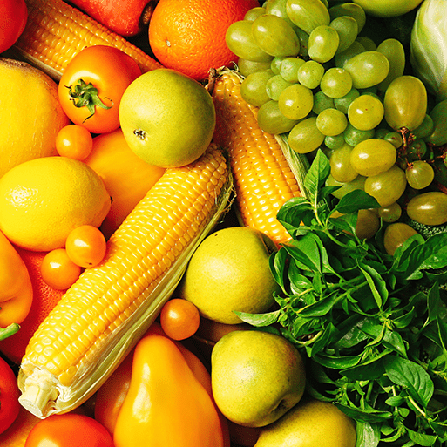 |  |  | Animal Safari  Companion 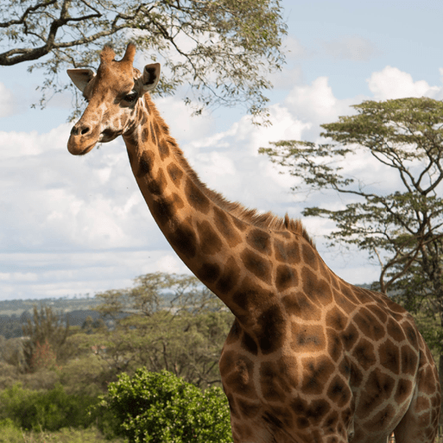 |  | On the Beach  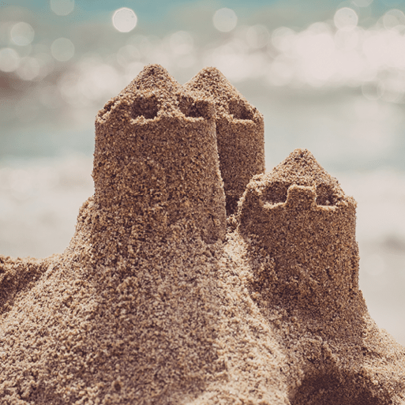
EYFS  Mini Project | Build it  Up  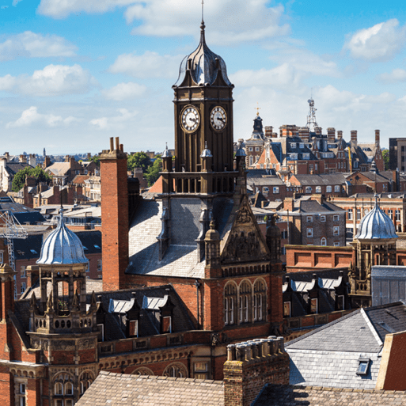 |  | Puppets and Pop ups  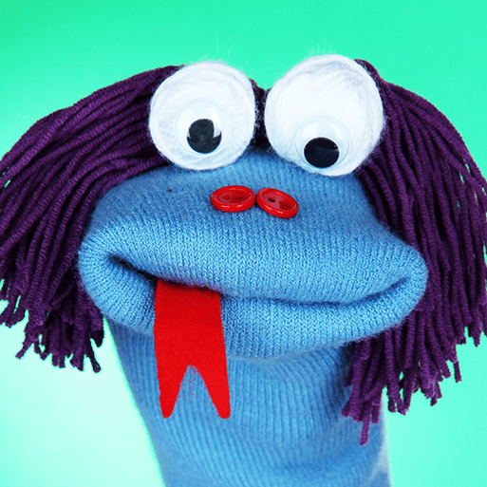  . |  | Stories and  Rhymes  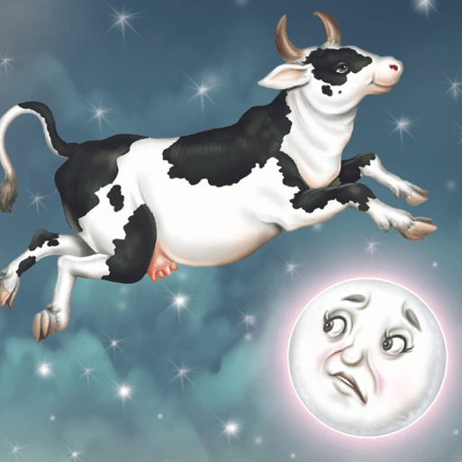 |  |  | Signs of  Spring  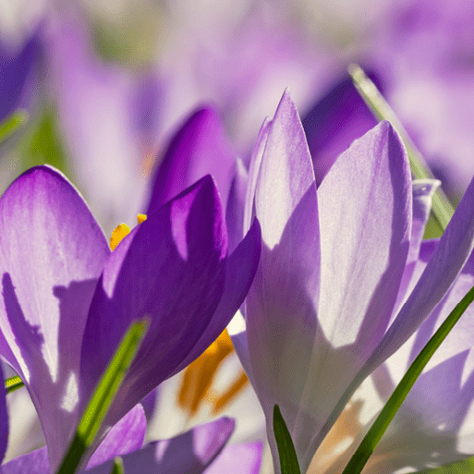 |  |  | Creep, Crawl, Wriggle  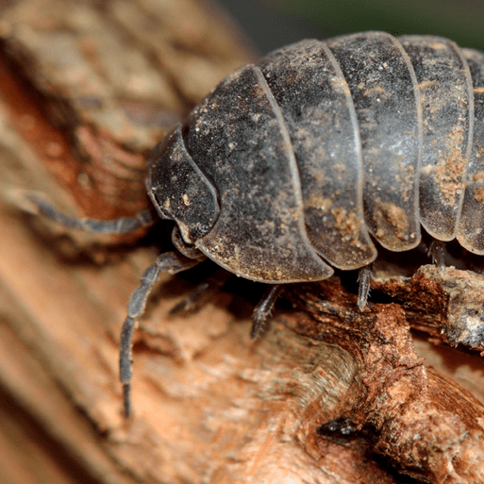 |  | Move it
 | Topic 1 | Topic 2 |  | Topic 3 |  | Topic 4 | Science |  | Science | Science |  | Science |  | Science | Art and Design  DT
KS1 | Movers and Shakers 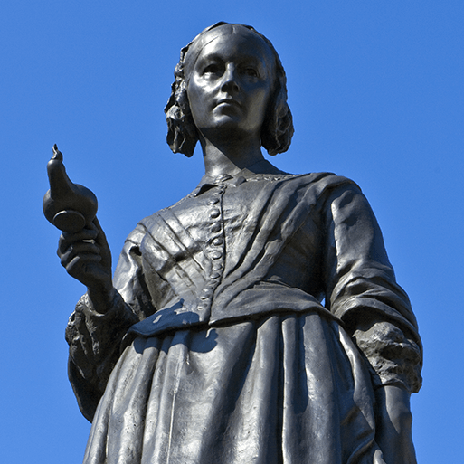  Focus - History | Let’s Explore the World  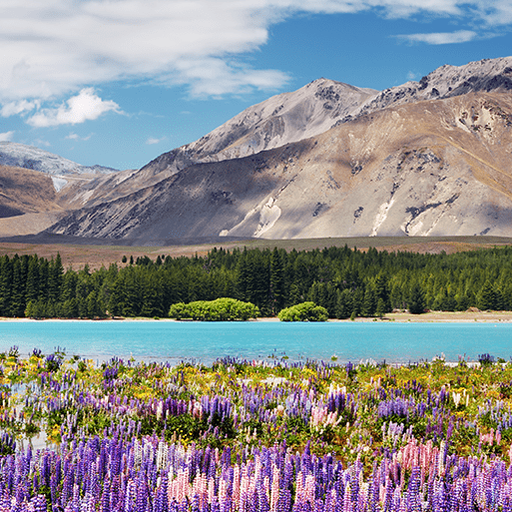  Focus - Geography |  | Coastline  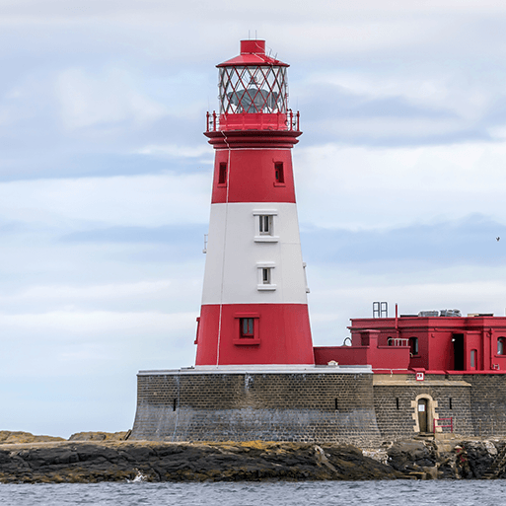  Focus - Geography |  | Magnificent Monarchs 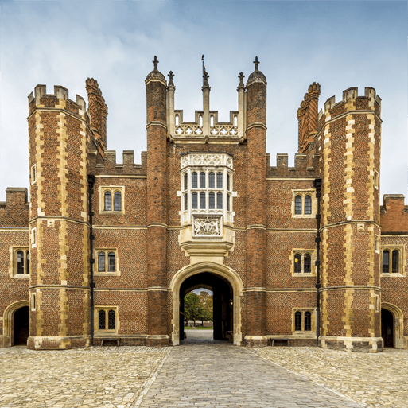  Focus - History | Human Survival |  | Habitats  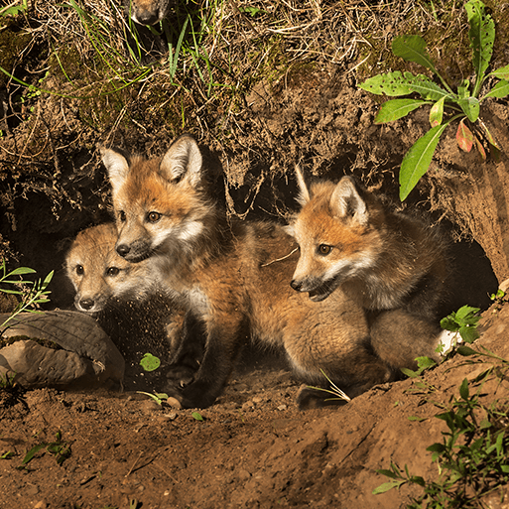 | Uses of Materials  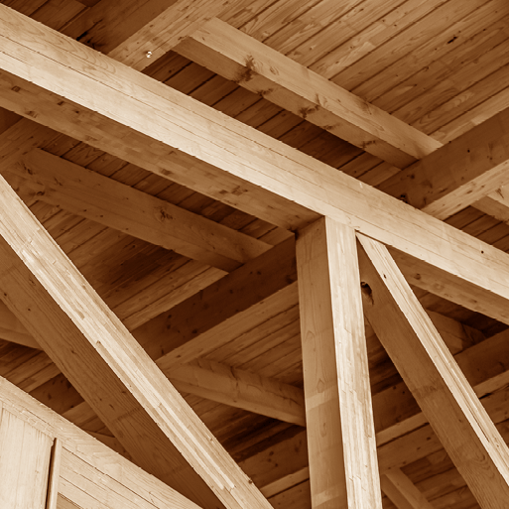 |  | Plant Survival  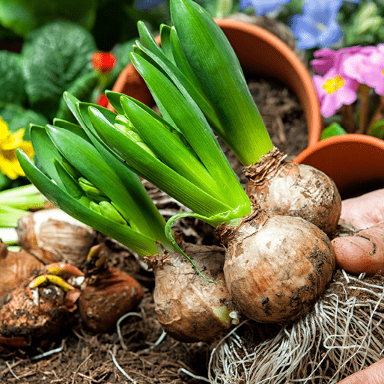 |  | Animal Survival  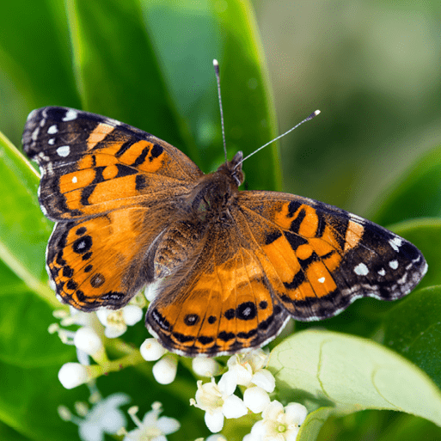 | A&D:  Mix It  Still Life  Flower Head  Portraits and Poses  D&T:  Remarkable Recipes  Beach Hut  Cut, Stitch and Join
 | Topic 1 | Topic 2 |  | Topic 3 |  | Topic 4 | Science |  | Science | Science |  | Science |  | Science | Art and Design  DT
LKS2 | Invasion  Companion  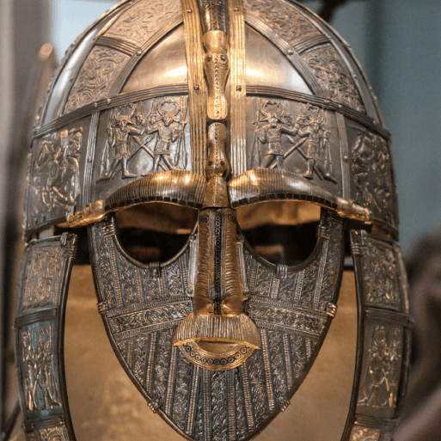  Focus - History | Misty Mountain, Winding River  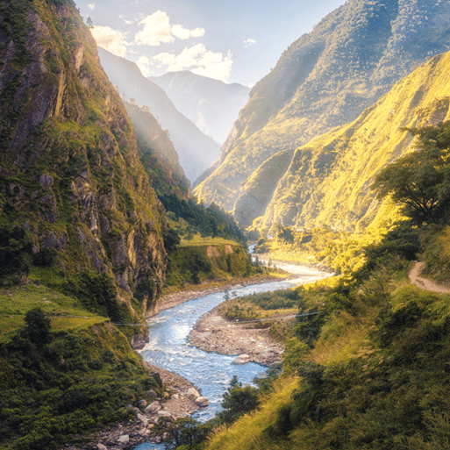  Focus - Geography |  | Ancient Civilisations  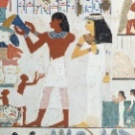  Focus - History |  | Interconnected World  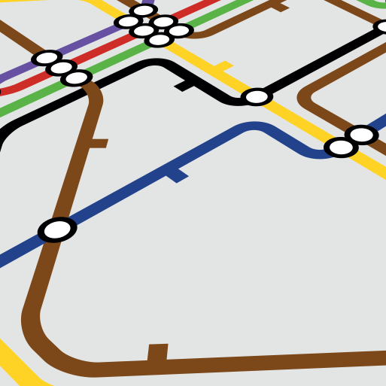  Focus - Geography | Food and the Digestive System  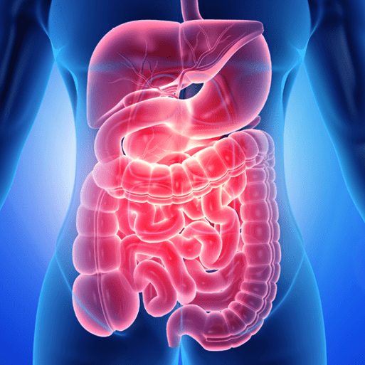 |  | Sound  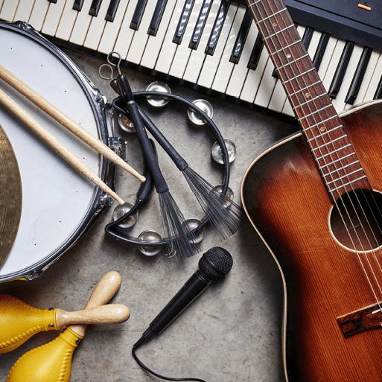 | States of matter  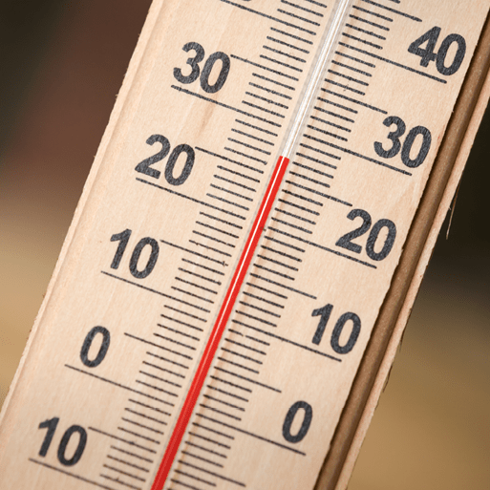 |  | Grouping and classifying  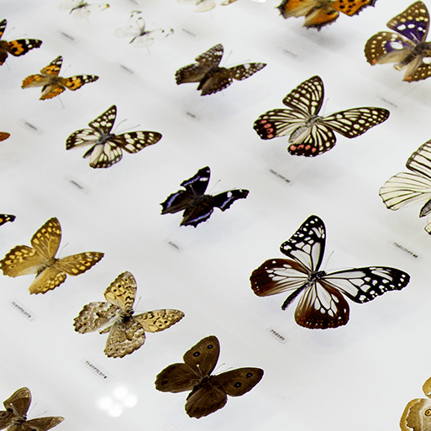 |  | Elec circuits and conductors  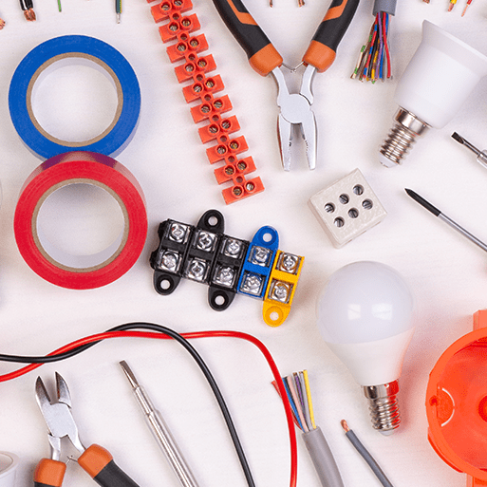 | A&D:  Contrast and Complement  Warp and Weft  Vista  Animal  Statues, Statuettes and Figurines  Islamic Art  D&T:  Fresh Food  Good Food  Functional and Fancy Fabrics  Tomb Builders

 | Topic 1 | Topic 2 | Topic 3 | Topic 4 | Science | Science | Science | Science | Art & Design  DT
UKS2 | Maafa  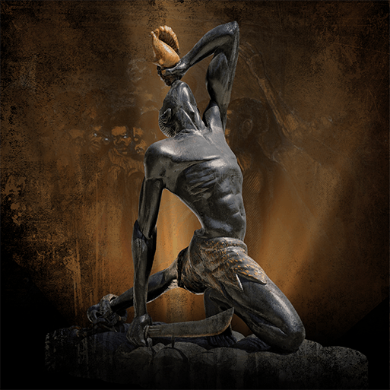  Focus - History | Our Changing World  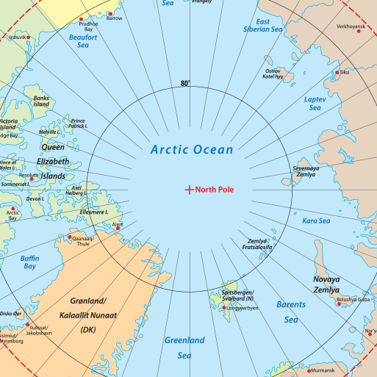  Focus - Geography | Frozen Kingdoms 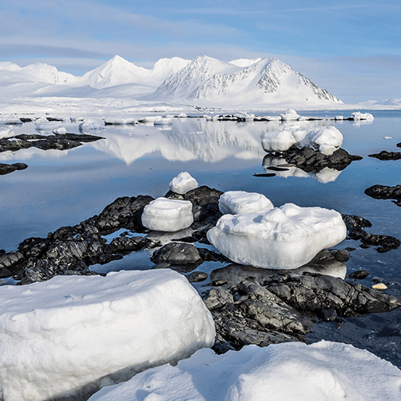Focus - Geography | Britain at War  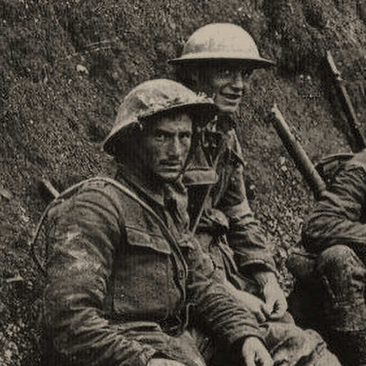  Focus - History | Circulatory System  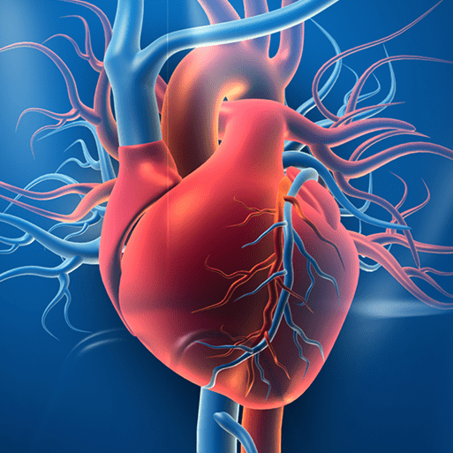 | Electrical Circuits and Components  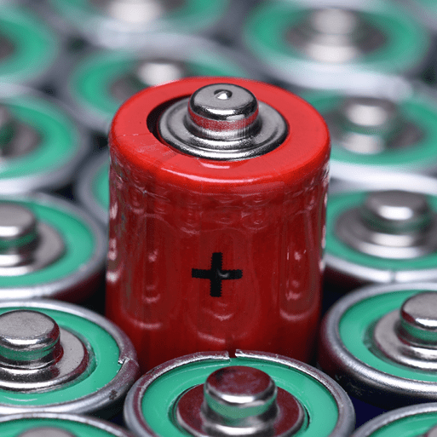 | Light Theory | Evolution and Inheritance  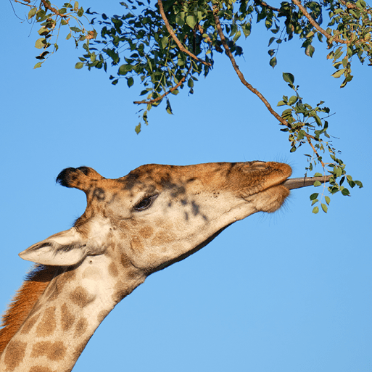 | A&D: Tints, Tones and Shades Trailblazers, Barrier Breakers Inuit Environmental Artists Distortion and Abstraction Bees, Beetles DT: Food for Life Engineer Make Do and Mend

