Kirkdale St Lawrence PE News Autumn 2
Kirkdale St Lawrence have had another busy half term of PE and school sport. Make sure you follow our school twitter @KSL_Kirkdale and @KealeyMiss for our sport updates.
Year 5 and 6 Football Team
Our Year 5 and 6 football team have enjoyed taking part in two competitions organised by Everton in the Community. They showed fantastic teamwork, resilience and determination when competing against other schools. We are looking forward to starting a football club and entering more competitions in spring term.

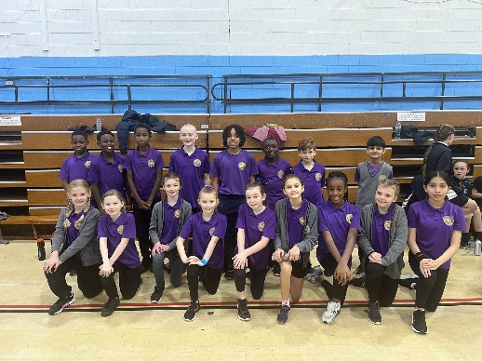

Volleyball
4 of our Year 6 children have enjoyed taking part in a volleyball development day at Holly Lodge.
Yoga
Various classes have enjoyed yoga sessions on a Wednesday. They have learned new skills and enjoyed some relaxation time.
Inclusive Festival
8 children from Key Stage 2 were given the chance to take part in the LSSP Inclusive Festival. They enjoyed parachute games, team building activities and multi challenge races.
Sports Hall Athletics
18 year 5 and 6 children were given the opportunity to compete against 6 other schools in an indoor Athletics Competition.
We are proud to have started working with Everton in the Community and the LFC Foundation.
Upcoming Events

Competitions and Sports Events
- Year 5 Swimming every Monday, starting 9th January.
- KS1 Matball Tournament, 30th January.
- Year 3/4 Highland Games, 10th February.
- Yoga every Wednesday, starting 22nd February.
- Year 6 boys Football, 24th February.
- Cross Country, 27th February.
- Year 5 Football, 2nd March.
- KS1 Intra School Matball Competition, 7th March.
- Cross Country, 9th March.

A new timetable for PE will be sent at the start of Spring term. Please make sure your children are in the correct school PE kit on the correct day!
Year 5 and 6 Cross Country
We are looking forward to competing in our Cross Country races again. We have two more races left of our first year competing in the Liverpool Primary Schools Cross Country League. The races will be held at Sefton Park on Monday 27th February and Wavertree on Thursday 9th March. Please make sure you follow our school results on liverpoolprimaryrunning.org

