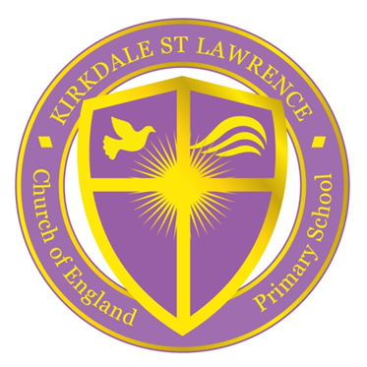
6.12.22
Kirkdale St Lawrence Church of England Primary School
Fonthill Road, Kirkdale, Liverpool L4 1QD
TEL: 0151 922 2775
School Office E-mail: kirkdale-ao@kirkdale.liverpool.sch.uk

Dear Families,
In Liverpool there has been increased rates of Scarlet Fever and so I thought it would be good to give you some information about it and what to look out for
WHAT IS SCARLET FEVER?
Scarlet fever is a contagious infection that mostly affects young children. It's easily treated with antibiotics.
WHAT TO LOOK OUT FOR
The first signs of scarlet fever can be flu-like symptoms, including a high temperature, a sore throat and swollen neck glands (a large lump on the side of your neck).  A rash appears 12 to 48 hours later. It looks like small, raised bumps and starts on the chest and tummy, then spreads. The rash makes your skin feel rough, like sandpaper.  You may also get a white coating or redness on the tongue.  It lasts for about 1 week. | 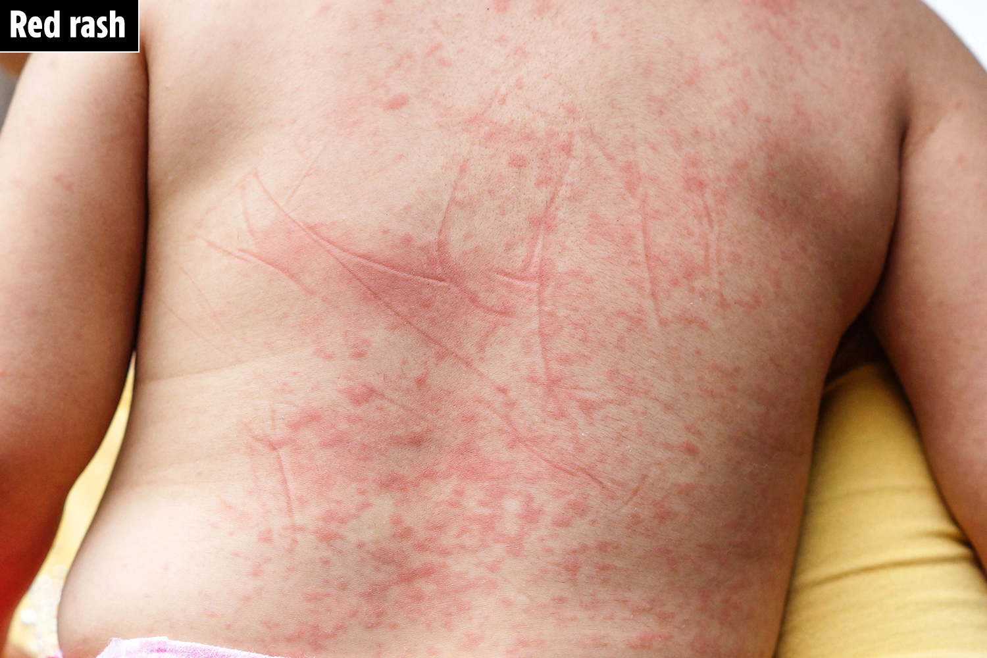
WHAT TO DO
Your child will need to see a doctor as they will need a course of antibiotics.
Once your child has been taking them for 24 hours they can return to school, if they are well enough.
There’s lots of extra information on the NHS website:
https://www.nhs.uk/conditions/scarlet-fever/

There has been lots of news in the media regarding Strep infections, which have sadly been fatal in a few cases. Therefore, if your child has Scarlet Fever and has been treated and is not getting better then you should seek further medical advice.

Let’s stay SAFE together
Mrs J Campbell
Headteacher

