
Nursery Class
Parent/Carer Information

Starting our Nursery Class
Your child will be taking a big step into the outside world when starting school. Your child can take a long time to get used to being with other children and adults who are outside the accustomed circle of family and friends. It is crucial therefore that you work in partnership with us at school to ensure your child grows in confidence, self-esteem and educationally.

Settling In
We help children to settle in happily to nursery by introducing them gradually into the nursery day. No child stays for the full session until we are sure they are ready. As each child is different, we tailor their admittance to suit their needs. The first day in nursery is a short visit and all parents/carers will be asked to stay for this visit – about one hour. The length of time your child spends in nursery will gradually be increased until they are staying a full session/day. The settling-in procedure is undertaken in an individual way for all children – please work in partnership with the nursery staff to ensure this is smooth and effective for your child.
The Teachers and Nursery Nurses are very experienced in settling children into nursery and will give you all their help and advice.

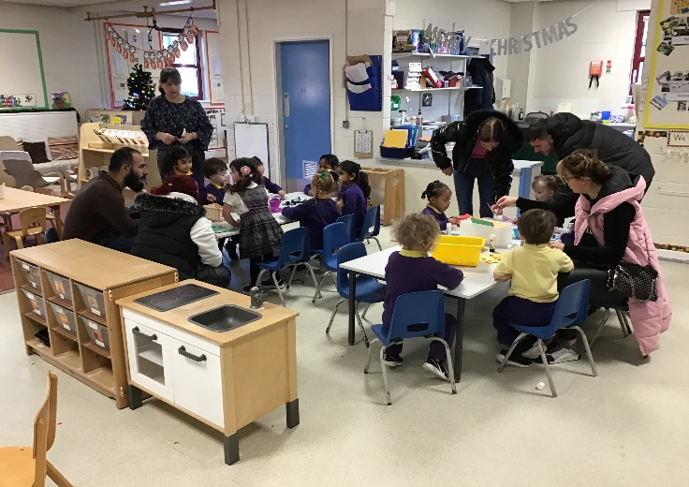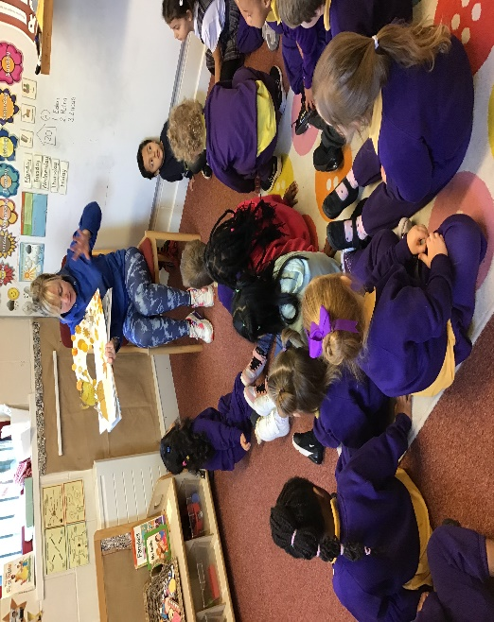

The Curriculum
We aim to encourage the all-round development of the child, socially, emotionally, physically, intellectually and spiritually in a safe, secure and stimulating environment through reference to the Early Years Foundation Stage guidance.

Early Years Staff
Nursery Class
Miss McArdle  Nursery Teacher  Early Years Lead Teacher | Mrs Hughes  Nursery Nurse  Tuesday - Friday |  | Miss Lee  Higher Level Teaching Assistant  Monday and Tuesday
Reception Class
Miss Williams  Reception Teacher | Mrs Hughes  Reception Teacher | Miss Foster  Nursery Nurse  Monday - Thursday |  | Miss Lee  Higher Level Teaching Assistant  Wednesday - Friday

Planning for children’s needs
Our curriculum is planned carefully for the developmental needs of all children. The phase of education for children aged 0-5 is called the Early Years Foundation Stage (EYFS), which explores children’s characteristics of effective learning through seven areas of learning and development:
- Communication and Language
- Physical Development
- Personal, Social and Emotional Development
- Literacy
- Mathematics
- Understanding the World
- Expressive Arts and Design
All areas of learning and development are connected to one another and are equally important. 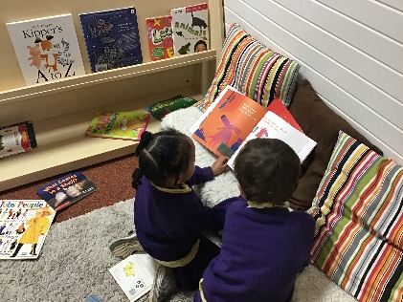 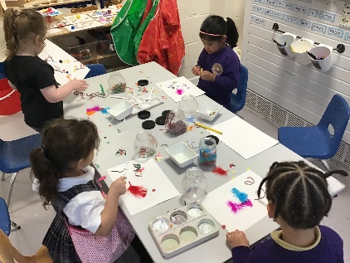 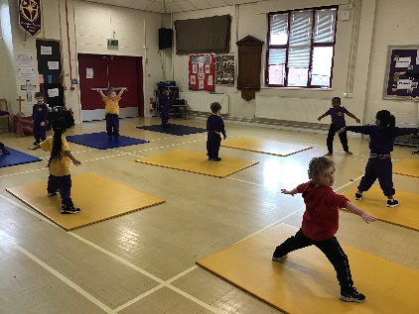

The Learning Environment
Although the nursery class may look like an informal playroom, everything has been selected and put out for a purpose. Everything is designed to help children learn and acquire necessary skills. For example; bead threading helps your child develop colour and shape recognition, sequencing, pattern making and hand-eye co-ordination, besides the creative pleasure the experience gives.
Your child will have the opportunity to experiment with a variety of materials, equipment and activities including paint, collage materials, sand, water, large and small construction sets, ‘small world’ toys such as railways or doll’s houses, dough, games, jigsaws, pens, pencils, crayons, paper, a wide range of fiction and non-fiction books, and role play.
Children have access each day to our outdoor environment and at certain times of the day can choose to stay indoors or go outside as they wish. Outside they have access to wheeled toys, climbing equipment, mud kitchen, quiet areas and water. Children also use the indoor hall for physical development activities on large apparatus, and for dance, music and movement activities.
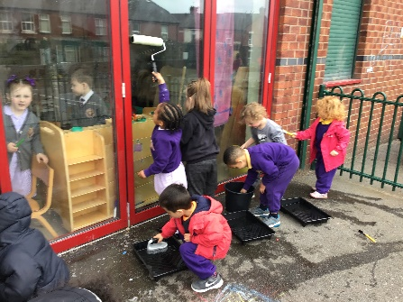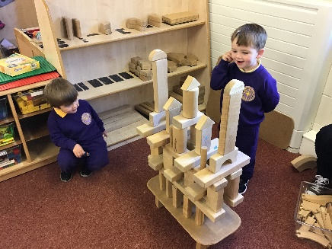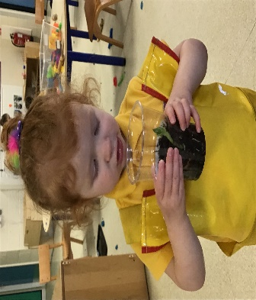

Assessment and record-keeping
Our assessment focuses on the whole child. Our Early Years staff will assess your child informally by making careful observations as they play and develop their understanding in all curriculum areas. Information that you give us is crucial in helping us with our observations. We will complete language and communication assessments (WELLCOMM) at various points throughout the year and parents’ evenings are held each term.

Parent/Carer Involvement
We welcome your involvement in your child’s education. We value your role as your child’s first and most enduring educator and hope we can work in partnership with you throughout your time with us. The Nursery staff are available at the beginning and end of each day to discuss matters with you.
We hold regular parent events such as stay and play, workshops and open sessions for you to come and play alongside your child and other children. We will always inform you of school events prior to the event.

What can you do to support your child?
Your child will need to become more independent in order to adjust happily into nursery. You can help them before they begin nursery by encouraging them to:
- Put on and take off their coat
- Look after themselves when they go to the toilet and be out of nappies by aged 3 years if no SEND needs
- Stop using a dummy and bottle
- Wash their hands and face
- Use a knife and fork
- Tidy up the books and toys that they have been using.

There are many ways in which you can share your child’s nursery experiences. For example:
- Talk with your child and listen to their questions. Take time to explain – your child is trying to make sense of our world!
- Reduce the amount of time exposed to electronic devices that hinder communication.
- Let your child help out around the house by for example sorting out the washing, pairing the socks, tidying up. There are many opportunities for mathematics and language in such activities, and children love to feel “useful”.
- Look at books with your child. just talking about the pictures raises children’s awareness of stories, information and language.
- Provide paper and pencils or pens for your child to draw or make marks on, or in the kitchen for messages or shopping lists. Let them have a go at this on their own – it doesn’t matter that it looks like scribble – this is very important!

Jewellery
Children should not wear jewellery in school. Nursery staff will remove any jewellery worn by children and return it to you at the end of the day. Jewellery can be easily lost and we cannot take responsibility if this occurs. Children with pierced ears should wear stud earrings only.

Nursery school dinners
If you are paying for school dinners, these must be paid for weekly via parentpay or in cash at the school office on the first morning your child has a nursery session each week. PLEASE NOTE: If this is not paid in advance, your child will not be allowed to stay for dinner.

Snack Money
We ask you to make a contribution of £1 per week. This will cover the cost of the snack, baking ingredients and other materials for nursery.
Snack-time is a very valuable experience for young children. They learn to take turns in selecting what they want to eat, develop good personal hygiene habits, talk to one another in a group situation, and become familiar with foods and customs from other cultures. The children will have the opportunity to drink milk or water at snack-time.

Special dietary requirements/allergies
If your child has any special dietary requirements or allergies to food and drink, please let nursery staff know.

Nursery times
Morning session 8.45am – 11.30am
Afternoon session 12.15pm – 3.10pm
30 hours (full time) for eligible parents.

Collecting your child
If you are unable to collect your child from nursery and have asked someone else, please let your child’s nursery staff know about this and give them the name and description of the person. If it is a ‘last minute’ arrangement, please telephone the school or send a note with the person collecting the child. Please do not be offended if we challenge the person collecting your child if you have not informed us of any change in collection. We have a responsibility for the safety of your child.
The policy of the school/centre is that your child cannot be collected from school by anyone under the age of 16. Also please note that any adult under the influence of alcohol or drugs will NOT be allowed to collect your child from nursery.

Nursery uniform
The nursery has a jog-suit, which is practical, comfortable and appropriate for young children attending nursery. During the summer no summer dresses or open toe sandals/jelly shoes are to be worn. All items of uniform are available to purchase from the school office.
PLEASE NOTE: From September 2024 children in our Reception class will also wear the jog-suit and yellow school t-shirt. Formal school uniform will be worn by children in Year 1 – Year 6.
Coat/Jacket
A coat is needed for outdoor play. All clothing should be clearly marked with your child’s name. Nursery staff will label your child’s clothing (especially sweatshirts) when this has not already been done, to avoid confusion for your child.

Attendance
Regular attendance at nursery is essential and provides a routine and pattern for Primary School. If your child is ill or cannot attend nursery for any reason please let school know by telephone on the first day of their absence.
If you child is ill in nursery it is important that we can contact you or a relative or friend if you are not in.
Please make sure we have at least TWO emergency contact numbers. Please keep this information up to date. All alterations must be given to staff immediately.
If your child has an infectious illness such as chicken pox, measles or conjunctivitis please let the school know.
Children should be fully fit before they return to nursery.

Child Protection
Parent/carers should be aware that the nursery will take any reasonable action to ensure the safety of it’s children. In cases where the nursery staff have reason to be concerned that a child may be subject to ill-treatment, neglect or other forms of abuse, the designated Safeguarding Lead / Headteacher will have no alternative but to follow Liverpool Child Protection Procedures and inform Children’s Services of the concern. Parents/carers will not always be fully informed of concerns unless the Headteacher is certain that the safety of the child will not be prejudiced by doing so.

We hope your child will be happy in our nursery class and that you will develop a partnership with us to ‘move your child forward in their learning’.

