Kirkdale, St Lawrence CE Primary School
FREE

Breakfast Club
Opens 8am
Last Entry 8:25am
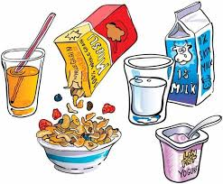
School Gate
opens at
8:45am
School Gate
closes at
8:55am


Wake up
Time for school

Nursery:
Morning: 8:45am-11:45am
Afternoon 12:15pm-3:15pm
EYFS and KS1 finish at 3:10pm
KS2 finish at 3:15pm
End of the Day

