Kirkdale St Lawrence CE School

A Policy for Behaviour and Relationships

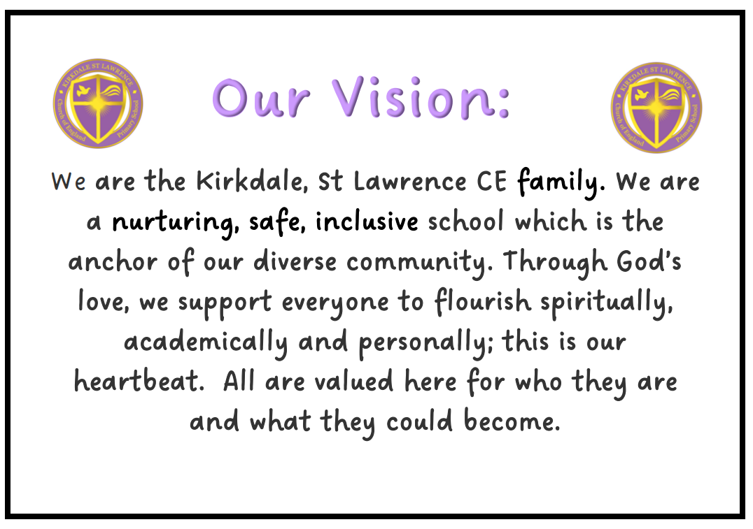

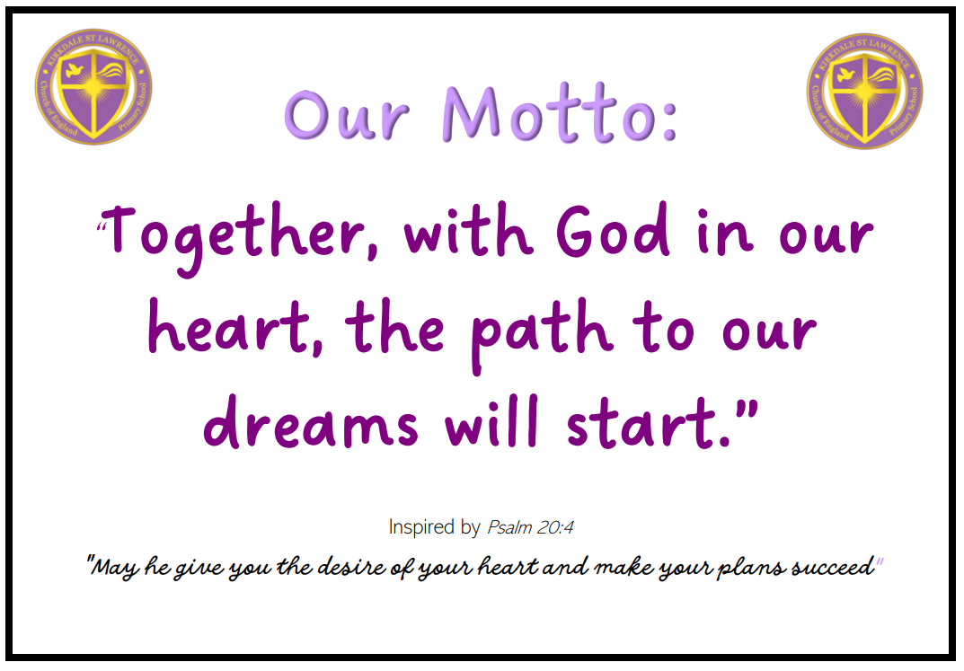
Overview
At Kirkdale, St Lawrence CE Primary, we strive to provide a nurturing and caring ethos so that the whole school community feels safe, valued and respected. An environment which promotes social and emotional well- being and respect for all enables everyone to reach their full potential.
Exemplary behaviour is central to all we do at Kirkdale, St Lawrence. This high standard of behaviour is expected and promoted at all times through every aspect of the school day. All members of staff will consistently model the high standards of behaviour and they will guide the children so that they are able to make the right choice.

It is vital that we work in partnership with parents/carers to ensure that the our Christian school values and Rules become central in their child’s life.
Purpose
The purpose of this policy is to guide teachers, pupils and parents on our restorative and relationship focused approach to behaviour management. Our approach is rooted in research on attachment friendly and trauma informed approaches. This will allow the pupils at Kirkdale, St Lawrence CE Primary School to learn in a calm, nurturing and safe environment which will support every child both emotionally and educationally to give them the best possible chance of success. We are committed to creating an environment where exemplary behaviour is at the heart of productive learning. Everyone is expected to maintain the highest standards of personal conduct, to accept responsibility for their behaviour and encourage others to do the same. Our behaviour policy guides staff to teach self-discipline not blind compliance. It echoes our school Christian values and vision with a heavy emphasis on respectful behaviour, a partnership approach to managing poor conduct and dynamic interventions between staff and learners. Consistency, and clear, calm, compassionate adult behaviour underpins this.

Aims
This policy aims to
- Provide a consistent approach to behaviour and relationships
- Ensure that excellent behaviour is a minimum expectation for all.
- Define what we consider to be excellent behaviour
- Summarise the roles and responsibilities of different people in the school community with regards to behaviour and relationships
- Outline the practice from this policy
- Build a community which values kindness, compassion and respect for all
- To promote community cohesion through excellent relationships.

Legislation and statutory requirements
This policy is based on advice from the Department of Education (DfE) on:
- Behaviour and discipline in schools
- Searching, screening and confiscation at school
- The Equality Act 2010
- Use of reasonable force in schools
- Supporting pupils with medical conditions at school
- special educational needs and disability (SEND) code of practice.

In addition, this policy is based on:
- Section 175 of the Education Act 2002, which outlines a school’s duty to safeguard and promote the welfare of its pupils
- Sections 88-94 of the Education and Inspections Act 2006, which require schools to regulate pupils’ behaviour and publish a behaviour policy and written statement of behaviour principles, and give schools the authority to confiscate pupils’ property

Hope | School Christian Values: | Courage
Compassion | Thankfulness | Trust

Kirkdale, St Lawrence CE Primary School Rules
- Ready
- Responsible
- Safe
Our 3 rules are displayed in all classrooms and are promoted and expected in all aspects of school life.

Definitions:
Non negotiables children will:
- Engage actively in learning
- Complete all learning tasks asked of them
- Wear full uniform with pride
- Displays commitment to all of our Values
- Follow KSL’s 3 rule – ready, responsible, safe

Unacceptable behaviour is when the above non negotiables aren’t adhered to.

Serious unacceptable behaviour is:
- Significant violence/aggression towards adults and or children
- Intentional damage to property
- Any form of bullying
- Sexual assault, which is any unwanted sexual behaviour that causes humiliation, pain, fear or intimidation
- Theft
- Intentional abusive, offensive, prejudicial behaviour
- Possession of any prohibited items. These include:
- Knives or weapons
- Alcohol
- Illegal drugs
- Cigarettes (including electronic cigarettes)
- Fireworks
- Pornographic images

Bullying
Bullying is defined as the repetitive, intentional harming of one person or group by another person or group, where the relationship involves an imbalance of power. Bulling is therefore:
- Deliberately hurtful;
- Repeated, often over a period of time

We take all forms of bullying very seriously (see appendix i) for breakdown of different forms of bullying) details of our approach to preventing and addressing bullying are set out in our Anti-Bullying Policy

Expectations of Adults
At Kirkdale, St Lawrence, we expect all adults to demonstrate the following behaviour: calmness, consistency, positivity, compassion, trust, gentleness, laughter, be supportive, respectful no matter what and praise good conduct publicly.

All staff
- Meet and greet at the door.
- Refer to ‘Ready, Responsible, Safe’
- Use our school values of Hope, Thankfulness, Trust, Compassion and Courage in conversations around relationships and behaviour
- Constantly and consistently model positive behaviour and build relationships.
- Plan lessons that engage, challenge and meet the needs of all learners.
- Use the recognition board throughout every lesson.
- Follow the KSL warning script as appropriate
- Be calm and give ‘take up time’ when going through the repair script.
- Follow up every time, retain ownership and engage in reflective dialogue with learners.
- Never ignore or walk past learners who are not following our 3 rules.
- Consistent and relentless routines are in place
- Use consistent language designed to de-escalate e.g I wonder…… I imagine…….I’ve noticed……

Pastoral Team
The pastoral team are not expected to deal with behaviour referrals in isolation. Rather they are to stand alongside colleagues to offer support, guidance and model in order to show a unified consistency to the children.
The pastoral team will:
- Be a visible presence in and around school to encourage appropriate conduct.
- Support staff in returning learners to learning by sitting in (when necessary) on repair conversation
- Write and support the implementation of individual plans for those children who require additional support.
- Provide appropriate individualised intervention.

Senior leaders
Senior Leaders are not expected to deal with behaviour referrals in isolation. Rather they are to stand alongside colleagues to offer support, guidance and model in order to show a unified consistency to the children.
Senior leaders will:
- Meet and greet learners at the beginning of the day on the school gate.
- Be a visible presence around the school and especially at transition times.
- Celebrate staff, leaders and learners whose effort goes above and beyond expectations.
- Regularly share good practice.
- Support everyone in managing learners with more complex or entrenched negative behaviours.
- Use behaviour data (recorded on CPOMS) to target and assess school wide behaviour policy and practice.
- Regularly review provision for learners who fall beyond the range of written policies.
- Carry out regular learning walks to support, coach and model expectations

Recognition and rewards
At Kirkdale, St Lawrence we believe that time should be spent celebrating the good behaviour of children across the school and we recognise and reward learners who go ‘above and beyond’ our standards.
We use a range of positive recognition strategies to reinforce expected behaviour, so that all children develop their self-esteem and sense of self-pride.
- Rewards in individual classes consist of: verbal praise to build emotional currency. All staff in school work together to support this positive ethos. Children will be regularly and consistently praised for adhering to our non-negotiables and demonstrating our school values. We recognise that the use of praise in developing a positive atmosphere in the classroom cannot be underestimated and can be as effective as a larger, more public reward.
- Shared praise – a board in the staff room where staff share the name of a child who has gone above and beyond so that the child can also receive praise from other staff.
- When a child produces outstanding work or has shown outstanding improvements in their work, they will receive a Headteacher Sticker form Mrs Campbell or Mrs Pollitt
- Weekly recognition of children who demonstrate going ‘above and beyond’ in all aspects of school life, will be recognised in Wednesday Celebration Worship where the child will be rewarded with certificate invitation to afternoon tea with Mrs Campbell the following Friday.
- Children who are recognised for showing our school values receive a Golden Ticket which allows them to jump to the queue on a day of their choice at lunchtime!
- Recognition Boards will be used to encourage social or learning behaviours. When a child is spotted by an adult displaying the agreed target their name will be added to the board. This is not intended to shower praise on the individual, it is a collaborative strategy – one team focused on one learning behaviour. If the whole class reach the daily target then children get to inform the Headteacher or Deputy of their success.

Managing behaviour
De-escalation of inappropriate child behaviour by staff avoids low-level behaviours escalating and becoming more serious. When a child/children are behaving in a way that is not appropriate, staff should use a range of strategies to support the pupil to get back on track without giving attention to the negative behaviour. Engagement with learning is always our primary aim. For the vast majority of our learners a gentle reminder is all that is needed. See appendix ii for ‘Practical steps in managing and modifying poor behaviour.’

If a range of strategies, such as those described above, have been implemented and have not had the required impact, staff should get alongside the pupil and deliver a positive and supportive script. Staff will thank them for listening, then walk away and give the child time to think and act positively. (appendix ii)

Important note
For some pupils, especially those with complex needs, including SEMH, the generic behaviour system/routines does not meet their individual support requirements. These pupils may have an individual support plan developed for them to meet their individual needs These plans are regularly reviewed and shared with all staff. All staff are responsible to follow the plans consistently, correctly and to support or request updates when required.

Serious unacceptable behaviour incidents (see above for definition)
Serious unacceptable behaviour incidents must be referred instantly to the Head or Deputy Headteacher. The ultimate consequences will be decided at discretion of the SLT. However, at the very least it will involve a phone call home plus a notification letter to parents/carer

Consequences
When pupils have been given the support and opportunities to make the right choices but do not modify their behaviour, children will be expected to ‘make good’ the situation as is appropriate during their own time. (See appendix iii)

Restorative Conversation:
A restorative conversation (repair script) needs to take place between the adult and the child when both are ready to engage effectively. This must include the adult that has dealt with the behaviour. Another colleague or line manager could support this. This should take the form of a coaching conversation for the pupil. Staff will have a repair script for the conversation. The repair conversation is:
1) What happened?
2) What were you thinking at the time?
4) Who has been affected?
5) Where did things go wrong for you?
6) How can we put this right?

CPOMS
CPOMS is our school’s online behaviour and safeguarding record which is used by every staff member to log any issues that arise in school. Each staff member has their own personal log in and every child is on the system. If there are any incidents that staff need to record or children’s behaviour that is a cause for concern can be logged on the system. Staff can assign incidents to other staff to look over or intervene if needed, notes can also be added to the incident. This gives us a record of individual children over the course of their time in this school. CPOMS is overseen by senior leadership and the pastoral team. The purpose of this is to give a complete picture of regular patterns of poor behaviour from individual children. Ensure that there is a written record kept over time that can be used in discussion with parents/carers and outside agencies.

Exclusion from school
At all times the school will seek to work with Parents/Carers to resolve any problems so that exclusion is avoided. However, continuous, serious unacceptable/unsafe behaviour could result in a fixed term exclusion for a given period of time.
In exceptional circumstances a ‘fixed’ term exclusion may be given immediately. Following this there will be a back to school meeting with child, parents/carers, pastoral team and Headteacher to review individual behaviour plan. In very rare circumstances it may be necessary to permanently exclude a child. This is a sanction of last resort when all other strategies have been explored and is something as a school we actively seek to avoid

Use of restraint by adults – Positive Handling
Physical intervention should be used as the last resort, using positive handling techniques and only by those trained in this. It may only be used when a child is in danger of / or causing injury to themselves or others. Staff should not put themselves in danger or risk injury. All incidents of restraint should be reported to the Headteacher immediately and must be recorded on CPOMS
Abuse towards staff
All incidents of aggressive, abusive, violent behaviour towards staff will be recorded and further legal advice taken. If necessary, the adult will be banned from the premises and police action will be taken.

Equal Opportunities
One of our key principles is that everyone will act with care and respect towards others at all times. We actively promote a positive, caring atmosphere for all the children in our school and foster respect for all races and religions.

We will not tolerate discrimination of any kind in deed or word. All incidents of bullying, racism and prejudice will be taken seriously and dealt with quickly. The Headteacher will reinforce the point that racist behaviour and prejudice are totally unacceptable in our school. If a particular child persists with inappropriate behaviour the Headteacher will inform parents/carers and invite them to take part in the problem solving process.
For more information about Equal Opportunities please refer to the school’s Equal Opportunities Policy.

Special Educational Needs and Disabilities (SEND)
The school recognises its legal duty under the Equality Act 2010 to prevent pupils with a protected characteristic from being at a disadvantage. Consequently, our approach to challenging behaviour may be differentiated to cater to the needs of the pupil. The school SENDCO (Emma Cottom) will evaluate a pupil who exhibits challenging behaviour to determine whether they have any underlying needs that are not currently being met. Where necessary, support and advice will also be sought from specialist teachers, Educational Psychologist, medical practitioners or other outside agencies in order to identify and support the specific needs. When acute needs are identified in a pupil, we will liaise with external agencies and plan support programmes for that child. We will work with parents to create the plan and review it on a regular basis.
For more information about SEN please refer to the school’s SEND Policy.
Searching:
School will search a child and have to right to do so when they believe the child has a prohibited item.
• knives and weapons;
• alcohol;
• illegal drugs;
• stolen items;
• any article that the member of staff reasonably suspects has been, or is likely to be used:
• to commit an offence, or
• to cause personal injury to, or damage to property of; any person (including the pupil).
• an article specified in regulations:
• tobacco and cigarette papers;
• fireworks; and
• pornographic images.
Under common law, school staff have the power to search a pupil for any item if the pupil agrees. The member of staff should ensure the pupil understands the reason for the search and how it will be conducted so that their agreement is informed. For further guidance please see government guidance:
https://assets.publishing.service.gov.uk/government/uploads/system/uploads/attachment_data/file/1091132/Searching__Screening_and_Confiscation_guidance_July_2022.pdf
Monitoring
This behaviour policy will be reviewed by the Headteacher and Safeguarding Governor on an annual basis.

The next review date for this Policy is November 2025

Paper copies of this Policy are available, upon request, from the school’s Assistant Admin Officer - Mrs Hart

Appendix i
Forms of bullying:
Type of bullying | Definition
Emotional | Being unfriendly, excluding, tormenting, name-calling, sarcasm, spreading rumours, teasing
Physical | Hitting, kicking, pushing, taking another’s belongings, any use of violence
Racial | Racial taunts, graffiti, gestures
Sexual | Explicit sexual remarks, display of sexual material, sexual gestures, unwanted physical attention, comments about sexual reputation or performance, or inappropriate touching
Cyber-bullying | Bullying that takes place online, such as through social networking sites, messaging apps or gaming sites

Appendix ii
Steps | Actions
Encouragement | Build emotional currency. Remind child of a time they were successful e.g remember yesterday you came in to class and sat at your table, listening to me which showed me that you were ready to learn
Reminder | Remind child (privately) of the three simple rules – Ready, Responsible, Safe
Warning | “This is now your warning. “I noticed that you chose to…..”  “That was the agreed rule about…that you have broken.”  “Do you remember when you were brilliant…last week or last lesson?”  “That is the _(child’s name)_ I want to see today!”  I’d like you to make the right choice now of…….. or you will have to………(tell child of the logical consequence for not making the right choice)”  “Thank you for listening.”  Then WALK AWAY and don’t look back. It is VERY IMPORTANT to finish by bringing their attention to past positive behaviour or the current good behaviour of the class. Normalising compliance.  If child makes the right choice make sure you give praise accordingly.
Consequence | ”Unfortunately you are still choosing to…….so the consequence is………
Repair script | This needs to be a lead by the adult who noticed the incorrect behaviour. Needs to take place when the adult is ready.
Managing and modifying behaviour

Suggested logical consequences

Behaviour displayed | Logical consequence
Non engagement in learning or non-completion of task | Child to complete missed learning in own time e.g. playtime/lunchtime/at home
Destruction of classroom/school environment | Child to fix whatever has been destroyed in their own time
Failure to act safely in a given context | Practice acting safely in a given context during own time
Failure to be ready and responsible during key transition points throughout the day | Practice getting ready responsibly in a timely manner

