Geography Curriculum Overview 24-25
 | Autumn 1 | Autumn 2 | Spring 1 | Spring 2 | Summer 1 | Summer 2
EYFS | Let's  Explore  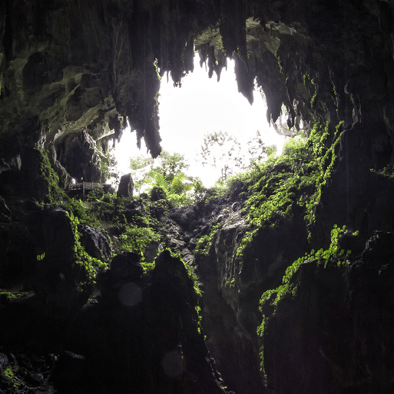  This project teaches children about the environments that they share with others, including their homes, school and places in the local community | Marvellous Machines  This project teaches children about the environments that they share with others, including their homes, school and places in the local community. | Long Ago  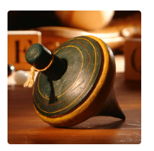  This project teaches children about how they have grown and changed since they were babies and how life in the past was different from today. | Ready Steady Grow  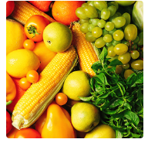  This project teaches children about food and farming and explores themes, including where food comes from, what plants and animals need to grow and survive and what constitutes a healthy lifestyle. | Animal Safari  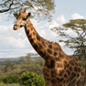  This project teaches children about the animals that live around the world, how to look after animals and the importance of caring for our local and global environments | On the Beach  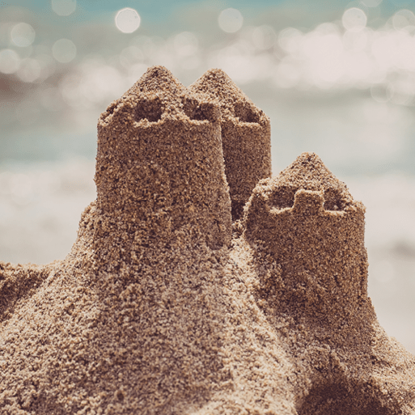  This project teaches children about the plants and animals that live at the seaside. It also explores holidays in the past and the importance of keeping safe in the Sun.
KS1 | Let’s Explore the World  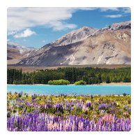  This essential skills and knowledge project teaches children about atlases, maps and cardinal compass points. They learn about the characteristics of the four countries of the United Kingdom and find out why there are hot, temperate and cold places around the world. They also compare England to Somalia. Children carry out fieldwork, collecting primary data in their locality to answer geographical questions.  Fieldwork- Traffic survey in local area.  Geography  Using an atlas; Using a compass; Using map keys; Locating the equator, Northern and Southern Hemispheres and North and South Poles; Hot, temperate and cold places; Comparing England to Somalia; Sustainability; Fieldwork |  |  | Coastline  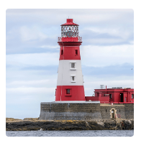  This project teaches children about the physical and human features of coastal regions across the United Kingdom, including a detailed exploration of the coastal town of Whitby, in Yorkshire.  Memorable experience- Coastal visit to New Brighton  Geography  Maps, globes and atlases; World seas and oceans; Human and physical features; Locational language; Compass directions; Physical processes – erosion; Changes over time; Tourism |  | Geography revision and retrieval practice
LKS2 | Interconnected World  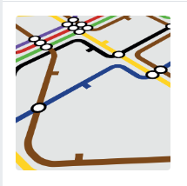  This essential skills and knowledge project teaches children about compass points and four and six-figure grid references. They learn about the tropics and the countries, climates and culture of North and South America. Children identify physical features in the United Kingdom and learn about the National Rail and canal networks. They conduct an enquiry to prove a hypothesis, gathering data from maps and surveys before drawing conclusions.  Geography  Compass points; Four and six-figure grid references; Tropics of Cancer and Capricorn; Countries, climate and culture of North and South America; Significant physical features of the UK; Renewable and non-renewable energy; National Rail network; UK canal network; Fieldwork; Local enquiry |  |  | Misty Mountain, Winding River  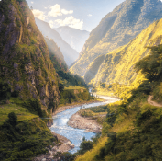  This project teaches children about the characteristics and features of rivers and mountain ranges around the world, including a detailed exploration of the ecosystems and processes that shape them and the land around them.  Memorable experience River visit  Geography  Rivers; Maps; Grid references; Contour lines; Physical processes – erosion, transportation and deposition; World rivers; Aerial images; Mountains; UK mountains; World mountains; Compass points; Water cycle; Soil; Altitudinal zones; Data analysis |  | Geography revision and retrieval practice
UKS2 | Our Changing World  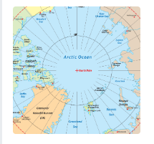  This essential skills and knowledge project revises the features of Earth, time zones and lines of latitude and longitude to pinpoint places on a map. Children find out more about map scales, grid references, contour lines and map symbols. They learn about climate change and the importance of global trade. Children analyse data and carry out fieldwork to find out about local road safety. They study patterns of human settlements and carry out an enquiry to describe local settlement patterns.  Geography  Features of Earth including the Arctic and Antarctic Circles; Time zones, Latitude and longitude; Map scale; Grid references, contours and symbols; Climate change, extreme weather and people; Worldwide trade; Natural resource management; Road safety; Fieldwork; Settlement patterns; Local enquiry |  |  | Frozen Kingdoms  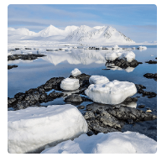  This project teaches children about the characteristics and features of polar regions, including the North and South Poles, and includes a detailed exploration of the environmental factors that shape and influence them.  Geography  Arctic and Antarctic regions; Lines of latitude and longitude; Polar climates; Polar day and night; Polar oceans; Polar landscapes; Climate change; Natural resources; Indigenous people; Tourism |  | Geography revision and retrieval practice

