DT Curriculum Overview A 25-26
 | Autumn | Spring | Summer
EYFS | Sparkle and Shine    Making tea light holders  Talk to the children about the different celebrations that happen in autumn and winter. Look at the Festival of light picture cards. Discuss how each festival has different types of lights and lamps to help people celebrate. Explain that the children are going to make special tealight holders.  Display a range of resources for the children to use and show examples of the different tealight holders by following the instructions below. Battery-operated tealights can be turned into either a diva lamp, lantern or candle.  Diva lamp  Use a ball of air drying, modelling clay to shape into a little pot, ensuring that a battery-operated tealight fits in the base. When dry, paint or decorate with glitter.  Lantern  Attach a cardboard or string handle to the top of a clear plastic cup using split pins. Cover the cup with coloured tissue paper, so that it makes colours as the tealight shines through.  Candle  Attach a battery-operated tealight to the top of a cardboard tube. Decorate the tube with shiny paper, paint and glitter.  Show the different types of tealight holders and talk about what type they would like to make and why. Give each child a Festive light design template and ask them to draw their design and tick the resources they will need.  Support the children to make their tealight holders. | Winter Wonderland    Remind the children about how they fed the birds using bird feeders and ask them why the birds need us to feed them during winter. Share the Bird food cake instructions with the children and explain that they are going to make bird food cakes to feed the birds during winter. Provide a selection of ingredients and yoghurt pots for the children to make their bird food cakes. When the bird food cakes are set, ease them from the yoghurt pots and choose places to hang them. Visit and observe the cakes regularly to see what has changed and which birds are feeding from them. | Splash  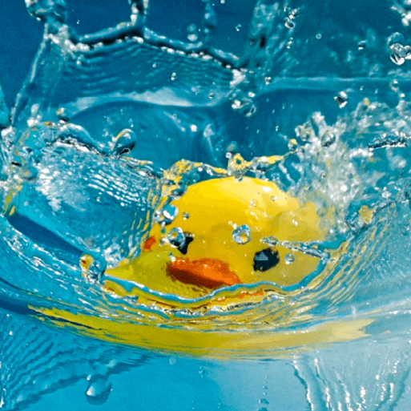  Display the Ice lolly picture cards and invite the children to talk about their favourite ice lollies. Ask the children how they think ice lollies are made and their ingredients. Share the Ice lollies recipe and read it with the children. Then, provide a selection of fruit juices, yoghurt, soft fruits and ice lolly moulds. Invite the children to plan an ice lolly using the Ice lollies recipe writing frame to create their unique recipe. Make ice lollies, following the children's recipes. Once frozen, go outside and let the children enjoy their lollies. Take photographs and encourage them to talk about how they tasted and what happened as they ate the lollies, using topic-related vocabulary.
KS1 | Shade and Shelter  Structures  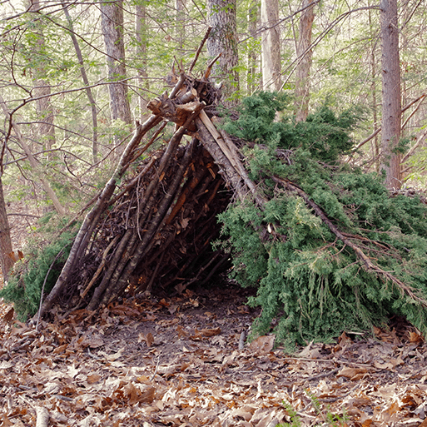  This project teaches children about the purpose of shelters and their materials. They name and describe shelters and design and make shelter prototypes. Children then design and build a play den as a group and evaluate their completed product. | Taxi!  Mechanisms    This project teaches children about the purpose of shelters and their materials. They name and describe shelters and design and make shelter prototypes. Children then design and build a play den as a group and evaluate their completed product. |  | Chop, Slice and Mash.  Cooking  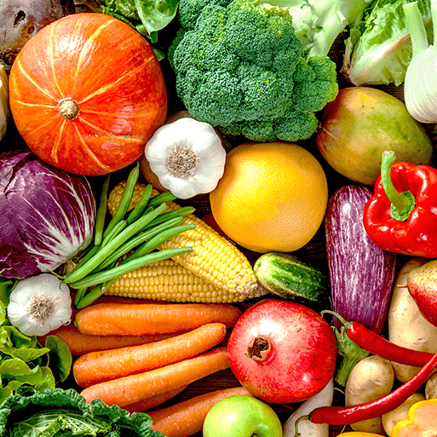  This project teaches children about sources of food and the preparatory skills of peeling, tearing, slicing, chopping, mashing and grating. They use this knowledge and techniques to design and make a supermarket sandwich according to specific design criteria.
LKS2 | Cook well, Eat well.  Cooking  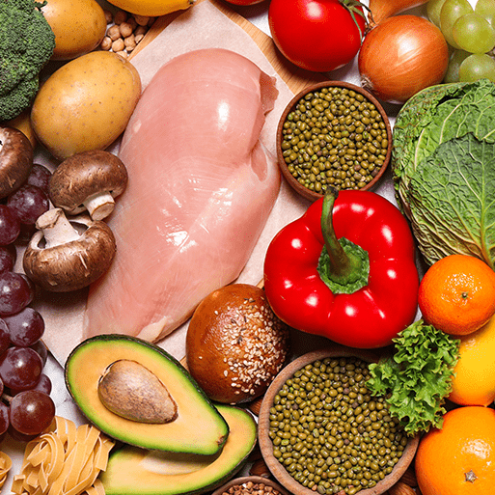  This project teaches children about food groups and the Eatwell guide. They learn about methods of cooking and explore these by cooking potatoes and ratatouille. The children choose and make a taco filling according to specific design criteria. | Making it move  Mechanisms  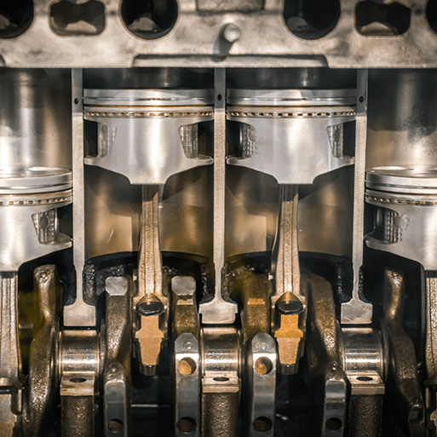  This project teaches children about cam mechanisms. They experiment with different shaped cams before designing, making and evaluating a child's automaton toy. |  | Greenhouse  Structures  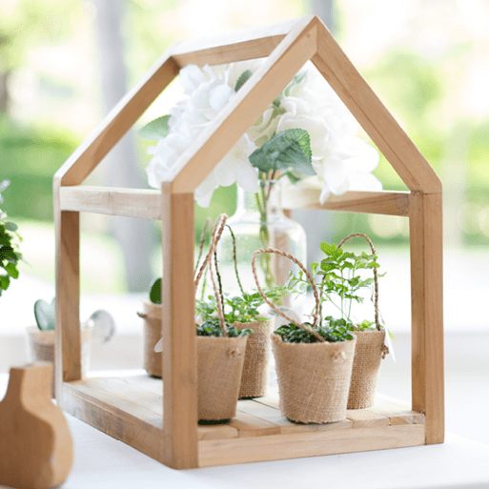  This project teaches children about the purpose, structure and design features of greenhouses, and compares the work of two significant greenhouse designers. They learn techniques to strengthen structures and use tools safely. They use their learning to design and construct a mini greenhouse.
UKS2 | Moving mechanisms  Mechanisms  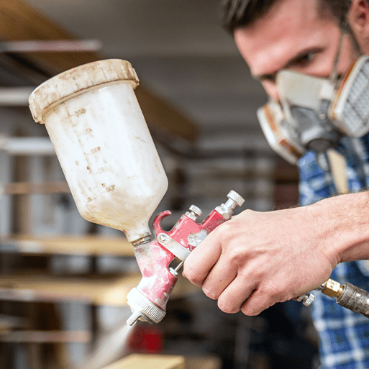  This project teaches children about pneumatic systems. They experiment with pneumatics before designing, making and evaluating a pneumatic machine that performs a useful function. | Eat the Seasons  Cooking  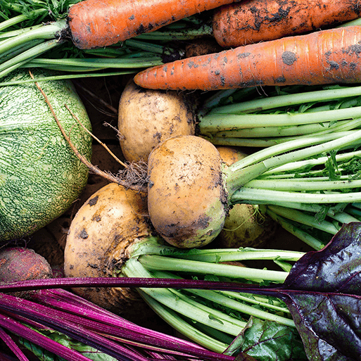  This project teaches children about the meaning and benefits of seasonal eating, including food preparation and cooking techniques.  Explain to the children that they will be designing and making a healthy, seasonal soup for four people, using some of the ingredients and techniques they have explored. |  | Architecture  Structures  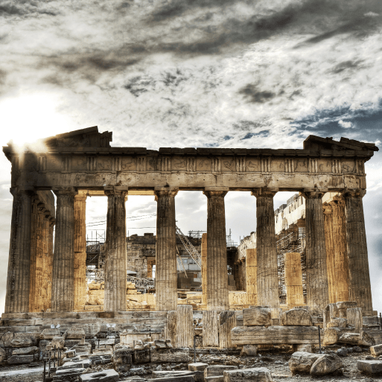  This project teaches children about how architectural style and technology has developed over time and then use this knowledge to design a building with specific features.

