Science Curriculum Overview 25-26
 | Autumn 1 | Autumn 2 | Spring 1 |  |  | Spring 2 |  | Summer 1 |  |  | Summer 2
EYFS  Driver project | Me and My Community  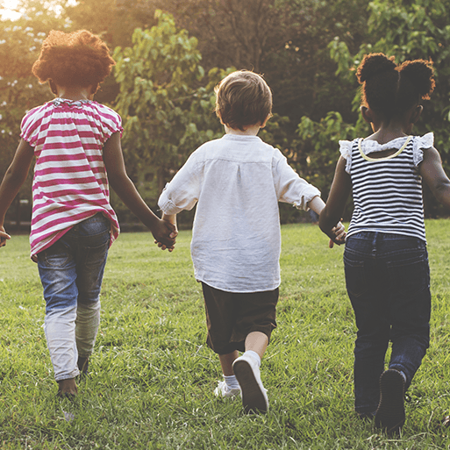  A community is made up of a group of people who share or live in the same place.  There are different types of communities, such as the family community, the school community and the local community. | Once Upon a  Time  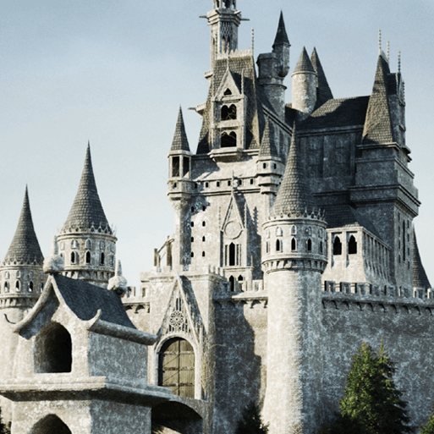  Make use of props and materials when role playing characters in narratives and stories. | Starry  Night    The environment changes through the day and the year.  Phenomena, such as day and night and weather can affect the way the environment appears.  The stars and Moon are always in the sky but the Sun's bright light hides them in the daytime. |  |  | Dangerous  Dinosaurs  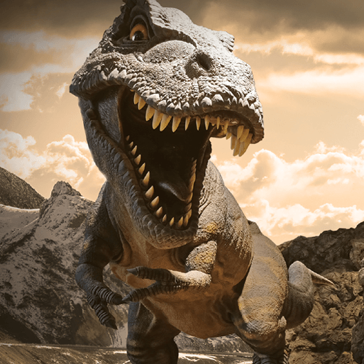  Explore the natural world around them, making observations and drawing pictures of animals and plants.  Understand that living things like dinosaurs lived millions of years ago.  That a palaeontologist studies fossils of living thing |  | Sunshine and Sunflowers  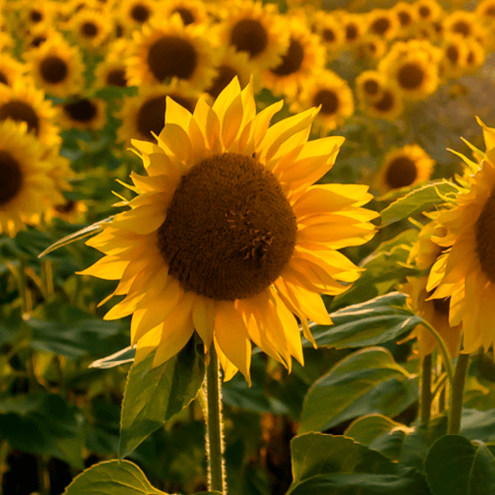  Explore the natural world around them, making observations and drawing pictures of animals and plants  A habitat is a place where living things live. Living things, including plants and animals, live in the local environment  Begin to observe and talk about living things in the local environment |  |  | Big, Wide  World  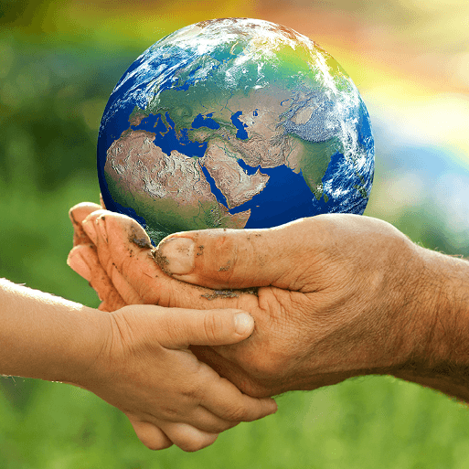  Teaches children about the global community to which they belong and explores how living things, communities and climates differ around the world.
EYFS  Mini project | Exploring  Autumn  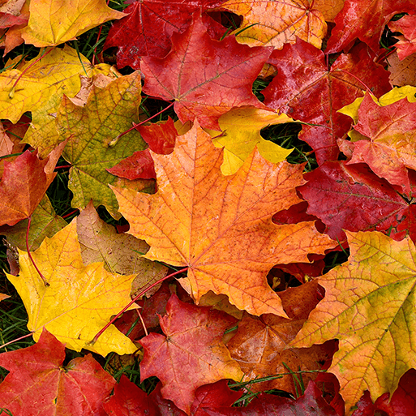  Teaches children about the natural changes that happen during the season of autumn, including how the weather changes, why trees lose their leaves and how wild animals prepare for winter. | Sparkle and  Shine    This project teaches children about the celebrations that take place during the autumn and winter seasons, and focus on the significance and symbolism of light at this time of year | Winter  Wonderland  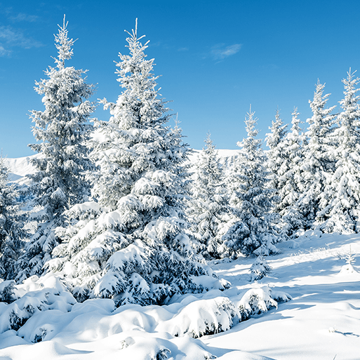  This project teaches children about the changes that happen during winter, including the types of weather associated with winter. It also explores places that have snow all year round and the types of animals that live there. |  |  | Puddles and Rainbows  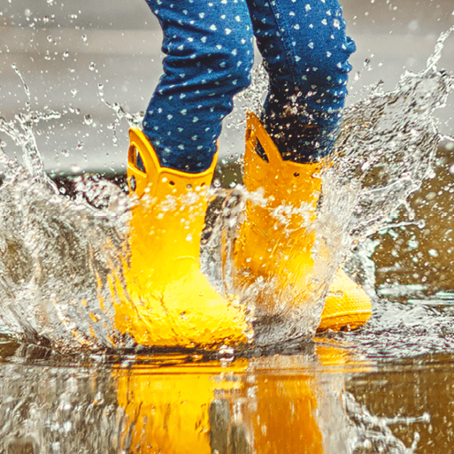  This mini project teaches children about the weather that happens during spring and allows them to explore natural phenomena, including rainbows. It supports them to explore colour in the natural world |  | Shadows and Reflections    This project teaches children about natural phenomena, including shadows, reflections and echoes. They explore how shadows are formed and how they can change |  |  | Splash!  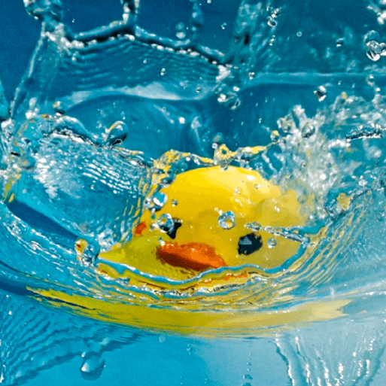  This project teaches children about water, including floating and sinking, freezing and melting, and why it is important for living things to stay hydrated.
KS1 | Everyday Materials  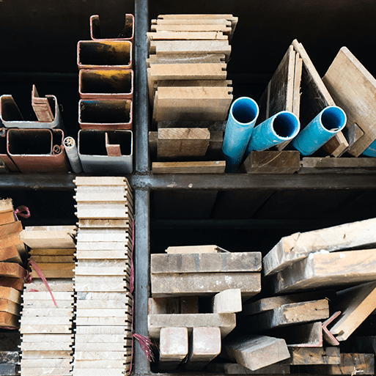  This project teaches children that objects are made from materials. They identify a range of everyday materials and their sources. Children investigate the properties of materials and begin to recognise that a material's properties define its use. | Human Senses  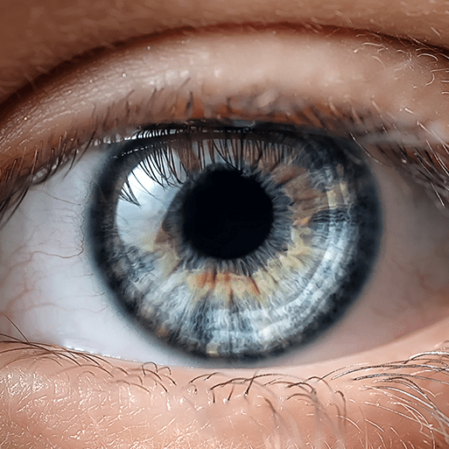  This project teaches children that humans are a type of animal known as a mammal. They name and count body parts and identify similarities and differences. They learn about the senses, the body parts associated with each sense and their role in keeping us safe. |  |  | Seasonal Changes  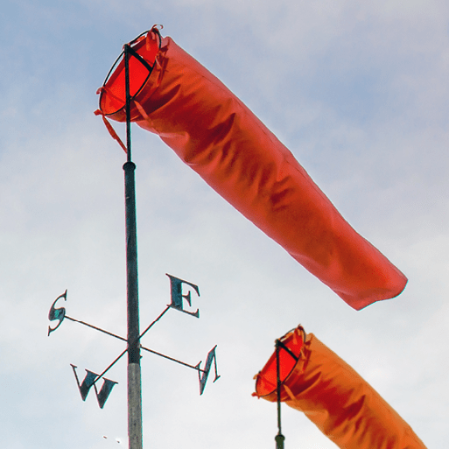  This project teaches children about the seasons, seasonal changes and typical seasonal weather and events. They learn about measuring the weather and the role of a meteorologist. Children begin to learn about the science of day and night and recognise that the seasons have varying day lengths in the UK. |  | Plant Parts  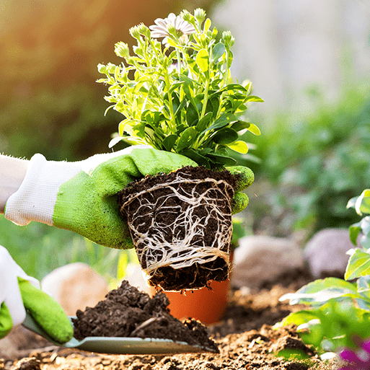  This project teaches children about wild and garden plants by exploring the local environment. They identify and describe the basic parts of plants and observe how they change over time |  | Animal Parts  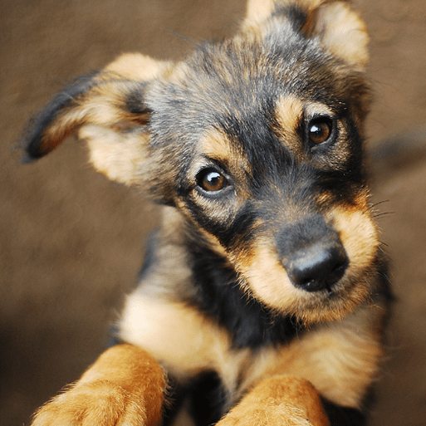  This project teaches children about animals, including fish, amphibians, reptiles, birds, mammals and invertebrates. They identify and describe their common structures, diets, and how animals should be cared for.
LKS2 | Animal Nutrition and the Skeletal System  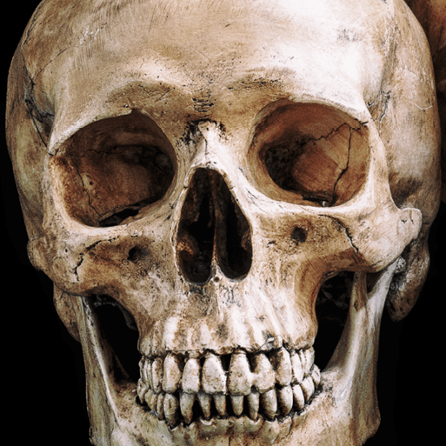  This project teaches children about the importance of nutrition for humans and other animals. They learn about the role of a skeleton and muscles and identify animals with different types of skeleton. |  |  | Forces and Magnets  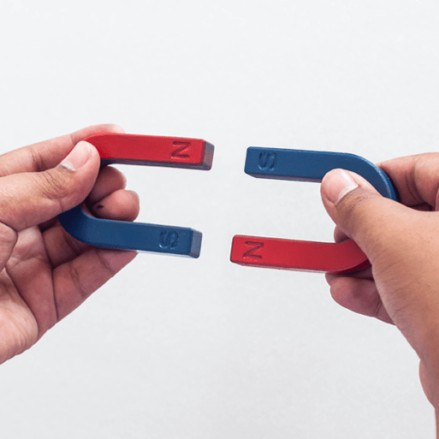  This project teaches children about contact and non-contact forces, including friction and magnetism. They investigate frictional and magnetic forces, and identify parts of a magnet and magnetic materials. |  |  | Plant Nutrition and Reproduction  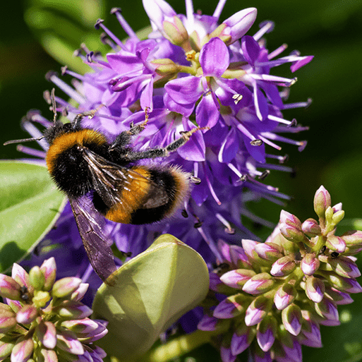  This project teaches children about the requirements of plants for growth and survival. They describe the parts of flowering plants and relate structure to function, including the roots and stem for transporting water, leaves for making food and the flower for reproduction. |  | Light and Shadows  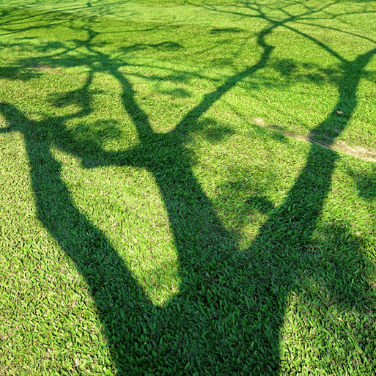  This project teaches children about light and dark. They investigate the phenomena of reflections and shadows, looking for patterns in collected data. The risks associated with the Sun are also explored.
UKS2 | Forces and Mechanisms    This project teaches children about the forces of gravity, air resistance, water resistance and friction, with children exploring their effects. They learn about mechanisms, their uses and how they allow a smaller effort to have a greater effect. | Earth and Space  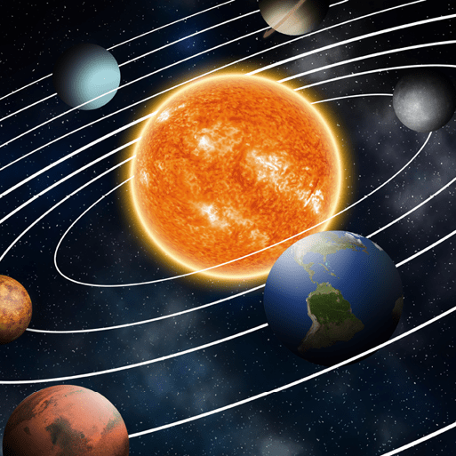  This project teaches children about our Solar System and its spherical celestial bodies. They describe the movements of the Earth and the other planets relative to the Sun, the Moon relative to Earth, and the Earth's rotation to explain day and night. |  |  | Human Reproduction and Ageing  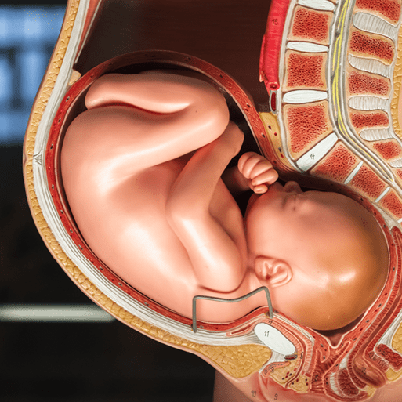  This project teaches children about animal life cycles, including the human life cycle. They explore human growth and development to old age, including the changes experienced during puberty and human reproduction. |  |  |  |  | Properties and Changes of Materials  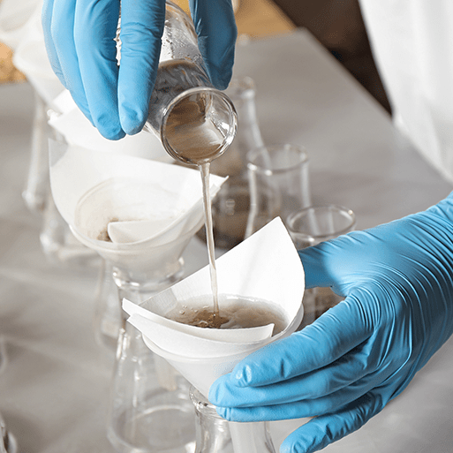  This project teaches children about the wider properties of materials and their uses. They learn about mixtures and how they can be separated using sieving, filtration and evaporation. They study reversible and irreversible changes and use common indicators to identify irreversible changes.

