Science Curriculum Overview 26-27
 | Autumn 1 | Autumn 2 |  | Spring 1 |  |  | Spring 2 |  |  | Summer 1 |  |  |  | Summer 2
EYFS  Driver project | Let's  Explore  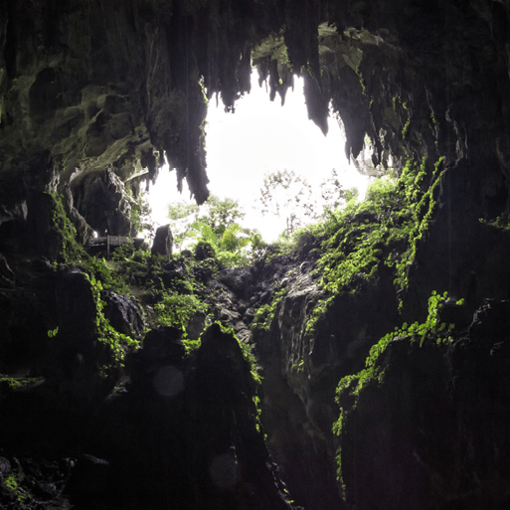  This project teaches children about the environments that they share with others, including their homes, school and places in the local community. | Marvellous Machines    This interest-led project teaches children about the technology that is part of their daily lives and how machines help us. The project gives children the opportunity to build and create marvellous machines |  | Long  Ago  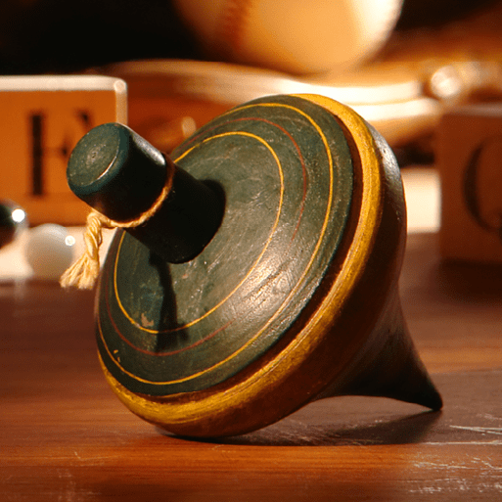  This project teaches children about how they have grown and changed since they were babies and how life in the past was different from today. |  |  | Ready Steady  Grow  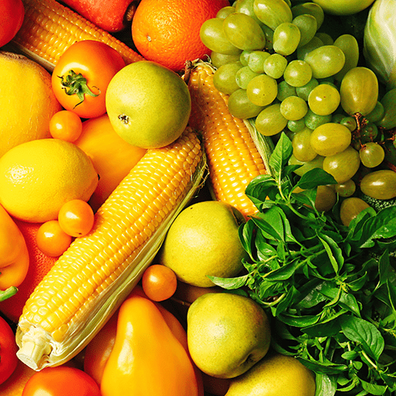  This project teaches children about food and farming and explores themes, including where food comes from, what plants and animals need to grow and survive and what constitutes a healthy lifestyle. |  |  | Animal  Safari  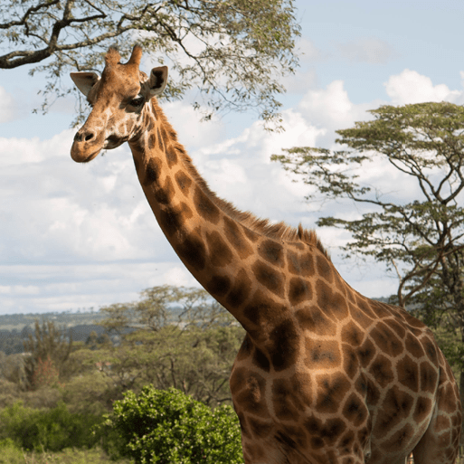  This project teaches children about the animals that live around the world, how to look after animals and the importance of caring for our local and global environments |  |  |  | On the  Beach  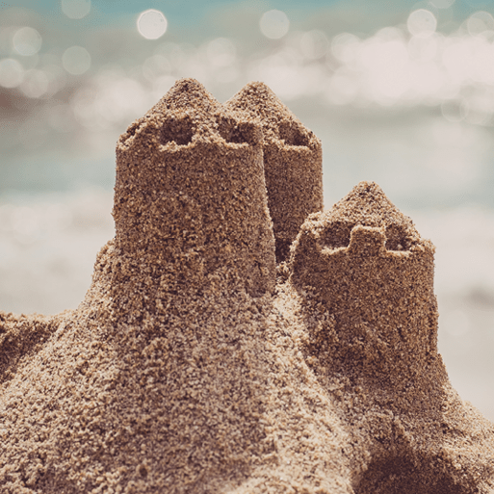  This project teaches children about the plants and animals that live at the seaside. It also explores holidays in the past and the importance of keeping safe in the Sun.
EYFS mini project | Build it  Up  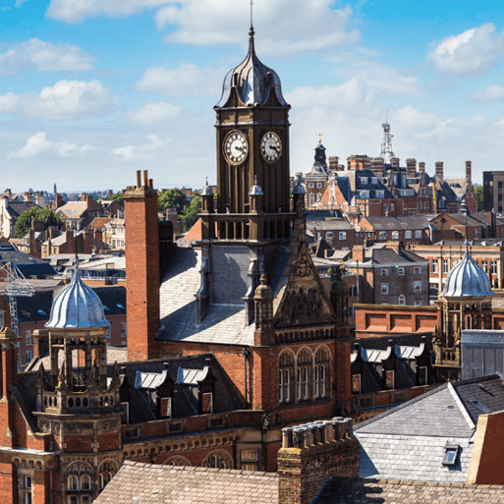  This project teaches children about structures and materials and gives them the opportunity to work in groups to create collaborative structures | Puppets and Pop ups  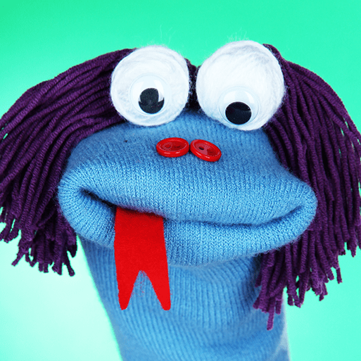  This creative project explores puppets and pop up books and gives children the opportunity to make puppets and use them to tell exciting stories. |  | Stories and  Rhymes  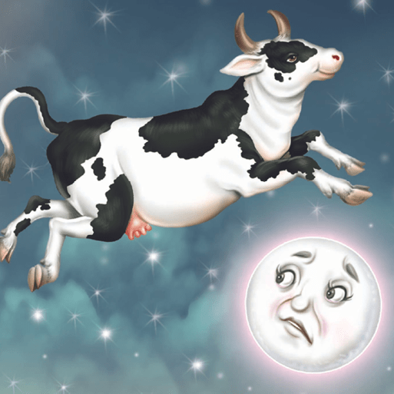  This project teaches children about traditional stories and rhymes and gives them the opportunity to play with words and learn new vocabulary. |  |  | Signs of  Spring  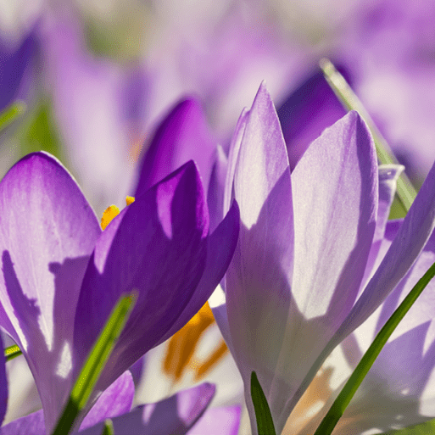  This project teaches children about the changes that happen during the spring, including weather and the festivals that are celebrated at this time of year. |  |  | Creep, Crawl, Wriggle  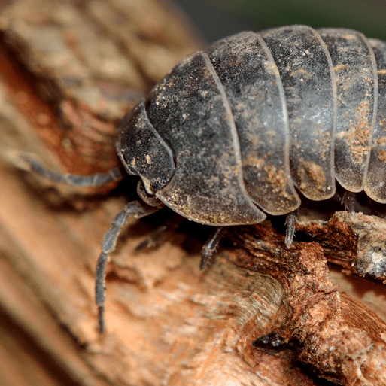  This mini project teaches children about invertebrates that live in their gardens and local environment. |  |  |  | Move it  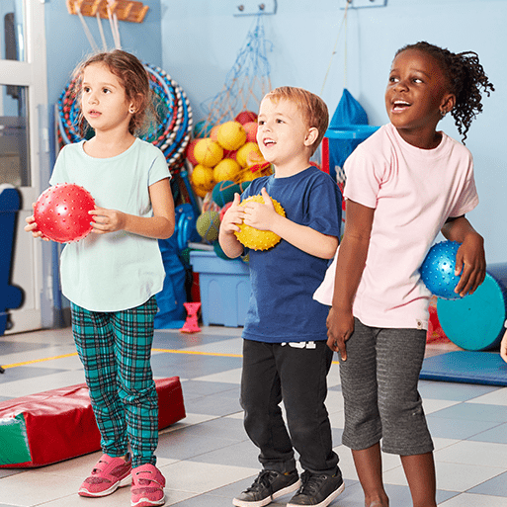  This mini project teaches children about the importance of exercise, sleep and a balanced diet, and explores outdoor, summer games and activities.
KS1 | Human Survival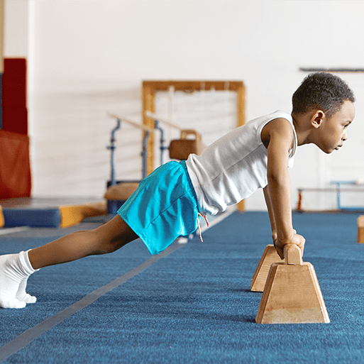  Use their observations and ideas to suggest answers to questions.  Notice that animals, including humans, have offspring, which grow into adults.  Describe the importance for humans of exercise, eating the right amounts of different types of food, and hygiene.  Perform simple tests.  Observe closely, using simple equipment.  Gather and record data to help in answering questions. |  | Habitats  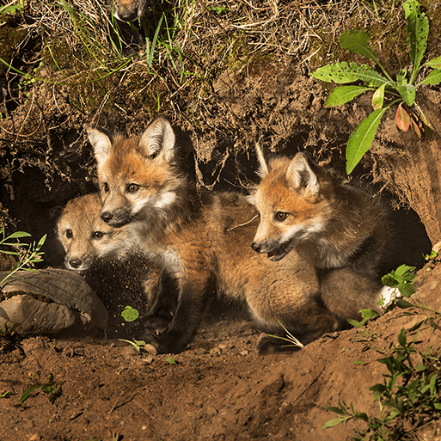  Identify that most living things live in habitats to which they are suited and describe how different habitats provide for the basic needs of different kinds of animals and plants, and how they depend on each other |  |  | Uses of Materials  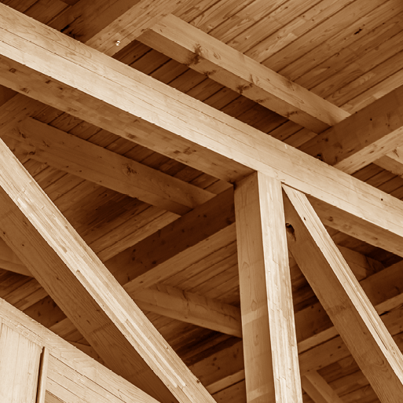  Identify and classify.  Find out how the shapes of solid objects made from some materials can be changed by squashing, bending, twisting and stretching.  Perform simple tests.  Observe closely, using simple equipment.  Use their observations and ideas to suggest answers to questions. |  | Plant Survival  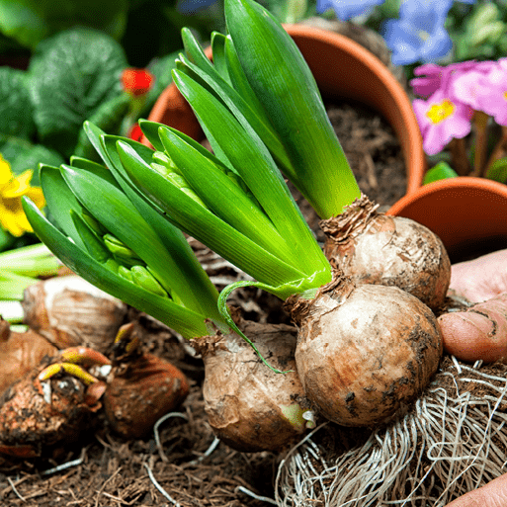  Observe and describe how seeds and bulbs grow into mature plants  Find out and describe how plants need water, light and a suitable temperature to grow and stay healthy. |  |  |  | Animal Survival  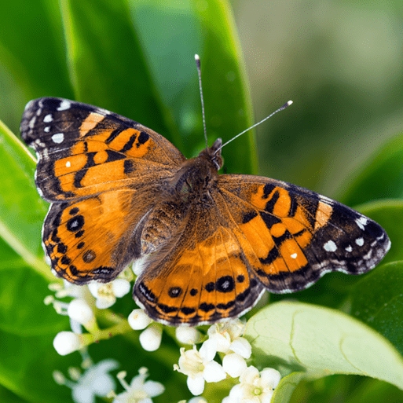  Explore and compare the differences between things that are living, dead, and things that have never been alive  Identify and name a variety of plants and animals in their habitats, including microhabitats  Describe how animals obtain their food from plants and other animals, using the idea of a simple food chain, and identify and name different sources of food
LKS2 | Food and the Digestive System  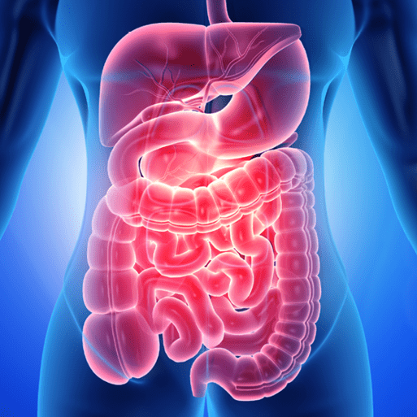  Describe the simple functions of the basic parts of the digestive system in humans  Identify the different types of teeth in humans and their simple functions  Construct and interpret a variety of food chains, identifying producers, predators and prey | Sound  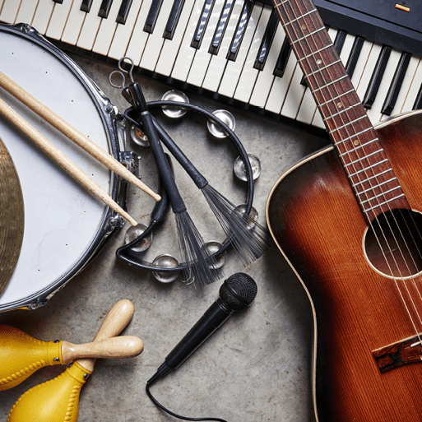  Identify how sounds are made, associating some of them with something vibrating  Recognise that vibrations from sounds travel through a medium to the ear  Find patterns between the pitch of a sound and features of the object that produced it  Find patterns between the volume of a sound and the strength of the vibrations that produced it  Recognise that sounds get fainter as the distance from the sound source increases |  |  | States of  matter  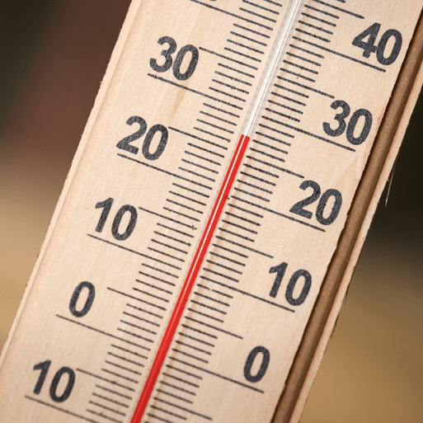  Compare and group materials together, according to whether they are solids, liquids or gases  Observe that some materials change state when they are heated or cooled, and measure or research the temperature at which this happens in degrees Celsius (°C)  Identify the part played by evaporation and condensation in the water cycle and associate the rate of evaporation with temperature |  |  | Grouping and classifying  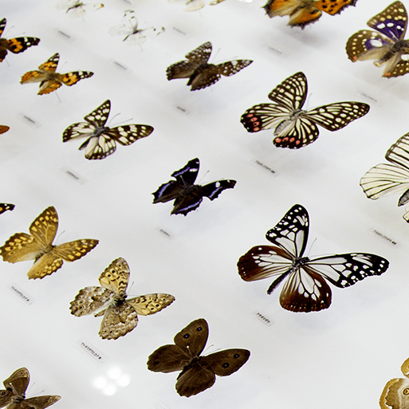  Recognise that living things can be grouped in a variety of ways  Explore and use classification keys to help group, identify and name a variety of living things in their local and wider environment  Recognise that environments can change and that this can sometimes pose dangers to living things |  |  | Electric circuits and conductors  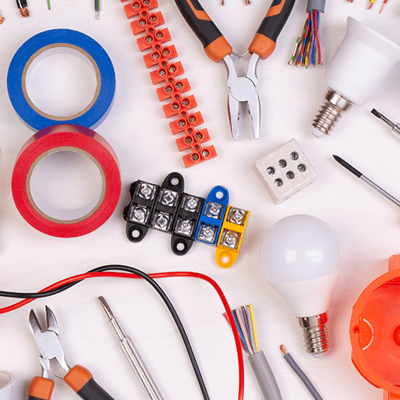  Identify common appliances that run on electricity  Construct a simple series electrical circuit, identifying and naming its basic parts, including cells, wires, bulbs, switches and buzzers  Identify whether or not a lamp will light in a simple series circuit, based on whether or not the lamp is part of a complete loop with a battery  Recognise that a switch opens and closes a circuit and associate this with whether or not a lamp lights in a simple series circuit  Recognise some common conductors and insulators, and associate metals with being good conductors
UKS2 | Circulatory System  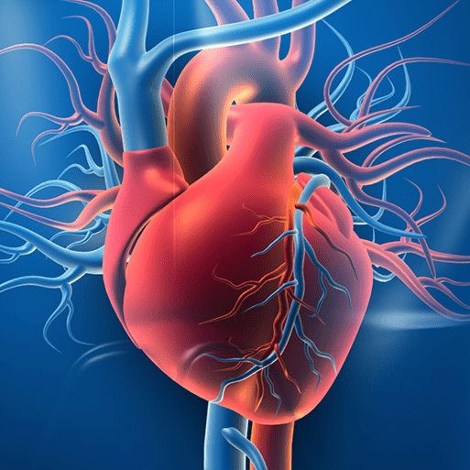  Identify and name the main parts of the human circulatory system, and describe the functions of the heart, blood vessels and blood  Recognise the impact of diet, exercise, drugs and lifestyle on the way their bodies function  Describe the ways in which nutrients and water are transported within animals, including humans | Electrical Circuits and Components  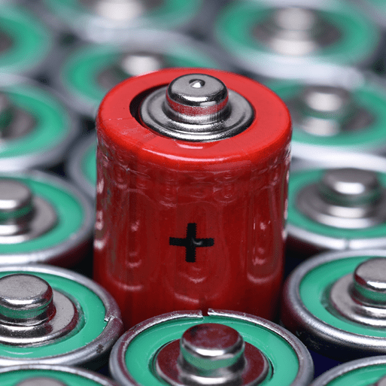  Associate the brightness of a lamp or the volume of a buzzer with the number and voltage of cells used in the circuit  Compare and give reasons for variations in how components function, including the brightness of bulbs, the loudness of buzzers and the on/off position of switches  Use recognised symbols when representing a simple circuit in a diagram |  |  |  | Frozen Kingdoms  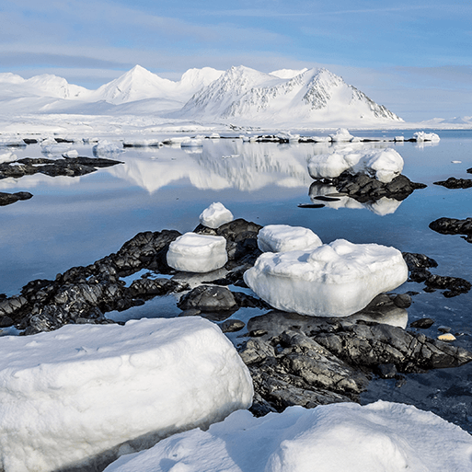  Describe how living things are classified into broad groups according to common observable characteristics and based on similarities and differences, including micro-organisms, plants and animals  Give reasons for classifying plants and animals based on specific characteristics  Explain that we see things because light travels from light sources to our eyes or from light sources to objects and then to our eyes  Use the idea that light travels in straight lines to explain why shadows have the same shape as the objects that cast them |  |  | Evolution and Inheritance  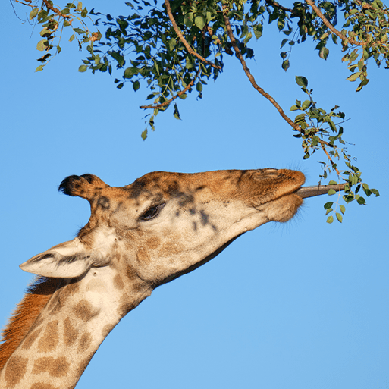  Learn to recognise that living things have changed over time and that fossils provide information about living things that inhabited the Earth millions of years ago  Recognise that living things produce offspring of the same kind, but normally offspring vary and are not identical to their parents  Identify how animals and plants are adapted to suit their environment in different ways and that adaptation may lead to evolution. |  |  |  | Light Theory    Recognise that light appears to travel in straight lines  Use the idea that light travels in straight lines to explain that objects are seen because they give out or reflect light into the eye

