

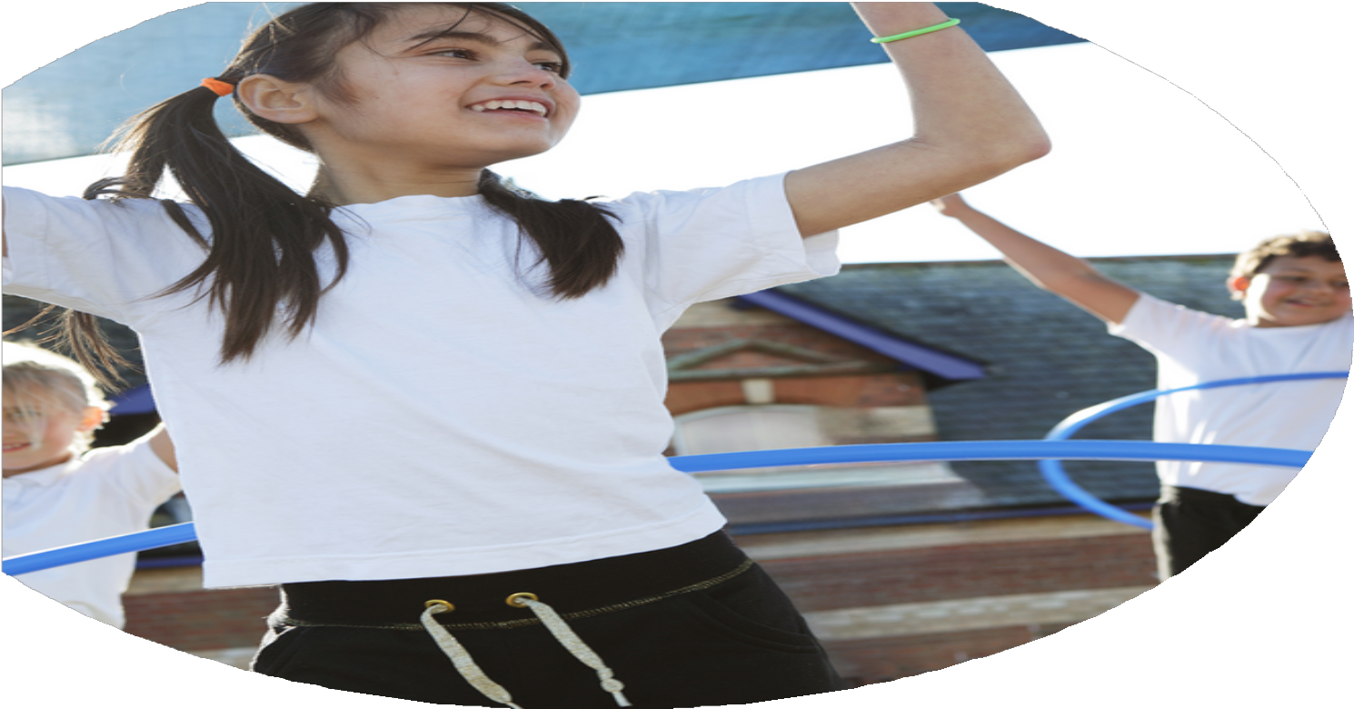
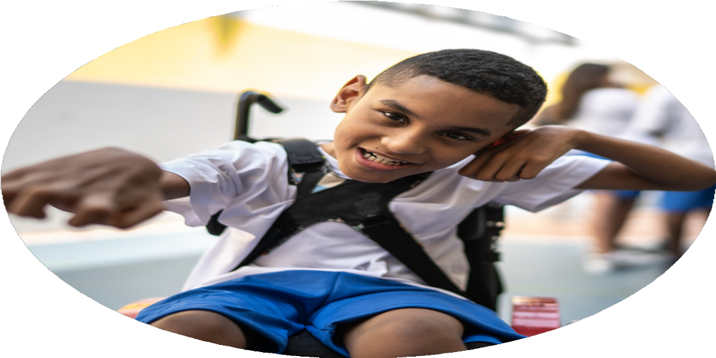
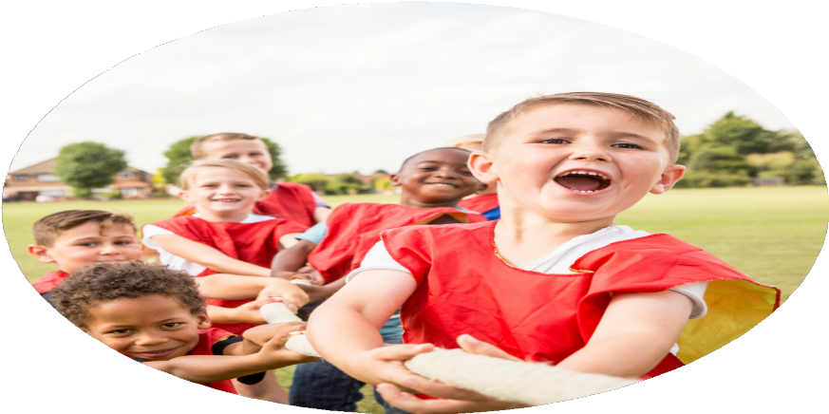



PE Funding

Evaluation Form

Commissioned by

Created by

Images courtesy of Youth Sport Trust
PE Funding Evaluation Form

It is intended that this template should be used as preparation for the completion of the statutory digital reporting tool being introduced this academic year. You can upload data (including swimming) from this template onto this platform once it becomes accessible.
Before you decide how you are going to use the funding for this academic year you should reflect and evaluate the impact of your use of the funding in 2024/25.
All spending of the funding must conform with the terms outlined in the Conditions of Grant document. The template is a working document that you can amend/update during the year.
Based on your evaluation of last year’s funding you should decide what you intend to do this academic year, how you will do it, and what impact you expect it to have.

It is important that the funding is used effectively and based on your school’s needs.
You must use the funding to make additional and sustainable improvements to the PE and sport in your school. You must develop and add to the PESSPA activities that your school already offers.

Summative digital reporting from June 2025 will continue to include swimming and water safety information therefore funding can be used to provide top-up lessons where necessary to ensure pupils meet national curriculum swimming requirements.
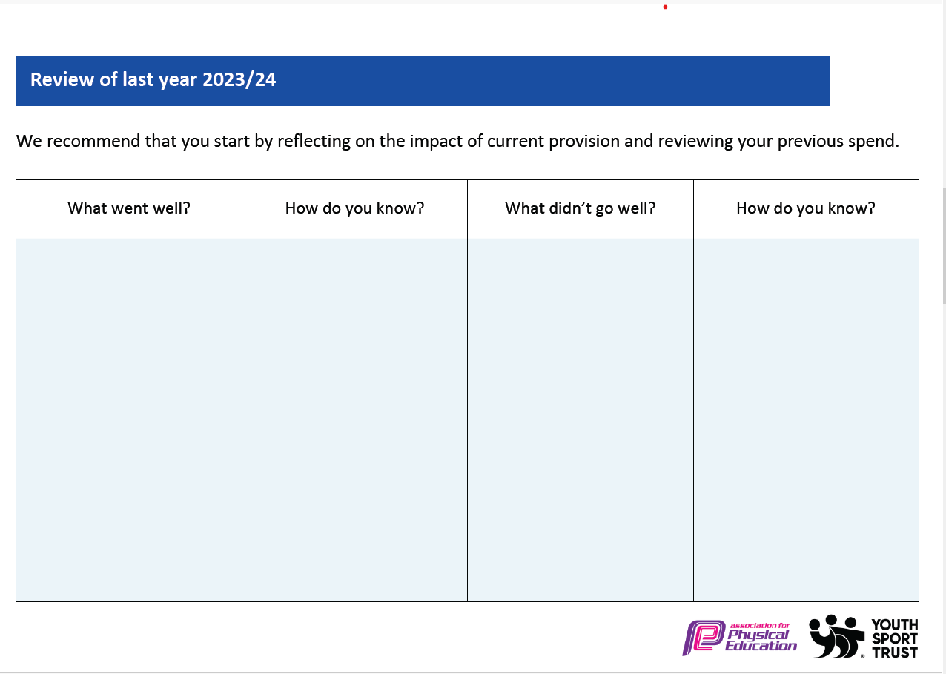
Review of last year 2202024/252525PAGE 24
What went well? | How do you know? | What did not go well? | How do you know?
Use of PE Premium funding to provide ‘top-up’ swimming for children in Year 6. | More children reached ability to complete 25m. | 18 children had to attend top up sessions as were not able to complete 25m swim
Received gold award quality mark | We were awarded the extra for the extra PE we have completed over the year.
Engaging a wide range of children within competitive sports opportunities | Children completed more opportunities to take part in sports competitions. | Lack of adults trained to use school minibus stopped us going on some competitions
Engaging a wide range of children in extra-curricular clubs | More extra-curricular clubs were completed. Focused on pupil premium children. | Similar clubs offered each year. Will be good to open up to a range of different clubs.
Sports day | Successful whole school sports day with 100% participation. Also organized an inclusive spots day for the children who could not participate on the field.

What are your plans for 2024/25?  Intent | How are you going to action and achieve these plans?  Implementation | Costings for each intent/ action
Increased knowledge and confidence of all staff, leading to high-quality curriculum PE lessons. | - PE CPD for 2 teachers through LSSP support  - Total PE+ Subscription (Planning and support)  - Yearly meeting with local advisor to support PE Subject Leader in their role. | £10,922
To increase physical activity levels to ensure children are meeting the active 30 minutes within school. | - Extra LSSP programmes aswell as PE e.g. balaceability, power  - Purchase of play equipment to be used at break times, lunchtime and during Active 10 | £516 for equiptment
To use school sport to develop social skills and promote physical activity outside of school. | - Competitions and Events, including LSSP Competitions for All Program  - Access to Liverpool school cross country
To promote ‘Healthy Lifestyles’ through PE, sport and physical activity. | - LSSP PE  - After school clubs  - Additional Swimming lessons for Year 5 and 6 children, to ensure they have reached National Curriculum Standards  - Cross country sessions | School minbus  Cross county league- - £100  Football league - £60
Intended actions for 2024/ PAGE 25
Expected impact/sustainability and supporting evidence

Intent / Action | What impact/intended impact/sustainability are you expecting? | How will you know? What evidence do you have or expect to have?
Increased knowledge and confidence of all staff, leading to high-quality curriculum PE lessons.  - PE CPD for 2 teachers through =  - Total PE+ Subscription  - = | Proposed Impact:  - Primary teachers will be more competent and confident to deliver effective curriculum PE lessons having taken part in 1 o 2 terms of PE  - Lesson observations will show pupils receive Quality First Teaching across the whole PE curriculum - supported through our Get Set 4 PE subscription, including making links to wider curriculum and supporting social development.  - Curriculum PE assessments will show an increased number of children working at age-related expectations for PE.  How sustainability will be achieved:  - CPD will have a lasting impact upon teaching and learning.  - Staff will be confident and competent teaching a range of curriculum areas. These in turn can be used to support our school in the future e.g. staff leading extra-curricular clubs. | How will impact be measured:  - Staff Voice across the year will show a growing confidence with the teaching of PE.  - Pupil Voice to highlight the impact of CPD upon PE lessons.  - Curriculum PE attainment data.  - Seesaw journals
To increase physical activity levels to ensure children are meeting the active 30 minutes within school.  - Extra-curricular clubs delivered by staff and LSSP | Proposed Impact:  - More pupils will be meeting their daily physical activity goal (30 minutes within school hours) compared to 2023/24.  - More pupils taking part in PE and Sport Activities outside of school hours compared to 2023/24.  - Increased number of children participating in breakfast and afterschool clubs.  - Greater number of children showing a good level of physical competence.  How sustainability will be achieved:  - Children will continue their participation within sports outside of school hours.  - Participation within clubs will contribute to children increasing physical competence. | How will impact be measured:  - Club registers and tracking documents  - Class discussions and pupil voice  - Curriculum PE assessment data (physical skills)
To use physical activity to support mental wellbeing. | Proposed Impact:  Pupils will report an increase in one or more of the key outcomes  - Resilience  - Self-esteem  - Attitudes towards physical activity  - Positive mental wellbeing  How sustainability will be achieved:  - will be transferred into the wider curriculum e.g. pupils showing a developing resilience in a range of curriculum areas, not just PE and sport related. | How will impact be measured:  - Staff Voice  - Pupil Voice
To use school sport to develop social skills and promote physical activity outside of school.  - Competitions and Events, including Competitions for All Program | Proposed Impact:  - Participation within competitive sport will support children to further develop teamwork skills, social and communication skills and supported wellbeing through a sense of ‘togetherness’.  - Increased number of children participating regularly within a sports club/ team as a result of our competitions provision across the year.  - Children will develop a love of a sport and the confidence to strive to achieve their best- leading onto more areas of school and personal life.  How sustainability will be achieved:  - Participation within competitions will lead to an increase in the number of children participating within sports outside of school hours. | How will impact be measured:  - Registers and participation tracking documents.  - Pupil Voice
To promote ‘Healthy Lifestyles’ through PE, sport and physical activity.  - Power programme | Proposed Impact:  - Children will develop a deeper understanding of healthy lifestyles, especially around how important the role of sleep is to health and wellbeing. | How will impact be measured:  - Pupil Voice  - Pupil lifestyle

Actual impact/sustainability and supporting evidence

Intent / Action | What impact/sustainability have you seen? | What evidence do you have?
Increased knowledge and confidence of all staff, leading to high-quality curriculum PE lessons.  - PE CPD for 2 teachers through 2 x Curriculum Support Programs  - Get Set 4 PE Subscription | Impact:  - Staff are confidently able to teach a term of PE using the Get Set 4 PE planning | Evidence:  Staff Voice:  - All staff reported an increase in confidence teaching PE
To increase physical activity levels to ensure children are meeting the active 30 minutes within school.  - Extra-curricular clubs delivered across the year by staff and LSSP | Impact:  Children have more opportunities to take part in physical activity by attending extra curricular clubs that school offers. | Evidence:  Extra-Curricular Clubs:  - Total number of clubs ran across the year:
To use physical activity to support mental wellbeing. | Impact:  Children are improving mental health using different strategies including the Power/ PALS and other LSSP programs | Evidence:  - Greater improvement in mental health and well being  - Children becoming more resilient
To use school sport to develop social skills and promote physical activity outside of school. | Impact:  Increase in sports competitions to give children a wide range of experience  Sports day participation | Evidence:  *All children did take part in Sports Day  Organized an inclusive spots day for children with SEND to take part in
To promote ‘Healthy Lifestyles’ through PE, sport and physical activity. | Impact:  Positive and healthy lifestyle improvement | Evidence:  - Children have improved their lifestyle choices  - Children aware of healthy meal choices.  - Children understand the importance of physical activity

Meeting National Curriculum requirements for swimming and water safety.
Priority should always be given to ensuring that pupils can perform safe self-rescue even if they do not fully meet the first two requirements of the National Curriculum programme of study

Question | Stats: | Further context - Relative to local challenges
What percentage of your current Year 6 cohort can swim competently, confidently and proficiently over a distance of at least 25 metres? | 68% | 34/50 (18 attended top up)
What percentage of your current Year 6 cohort can use a range of strokes effectively [for example, front crawl, backstroke, and breaststroke]? | 52%
What percentage of your current Year 6 cohort are able to perform safe self-rescue in different water-based situations? | 64%
If your schools swimming data is below national expectation, you can choose to use the Primary PE and sport premium to provide additional top-up sessions for those pupils that did not meet National Curriculum  requirements after the completion of core lessons. Have you done this? | Yes
Have you provided CPD to improve the knowledge and confidence of staff to be able to teach swimming and water safety? | No

