Year 2
Core Curriculum
English
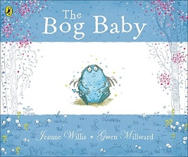 | 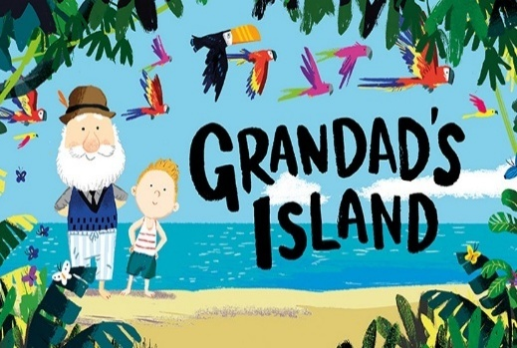
Reading and Writing  Bog Baby using the Ready Steady Write scheme will help children read and write a simple story with a clear beginning, middle and end. Children will learn to describe characters and settings using adjectives and action words and talk about how characters feel. When writing, they create their own short story using the past tense, simple sentences, basic punctuation and time words, often by inventing a new magical creature. | Reading and Writing  Grandad’s Island using the Ready Steady Write scheme will help children read a simple story with a clear beginning, middle and end. Children will talk about how the characters feel using the pictures and the story. When writing, they create a short story using the past tense, simple sentences and basic punctuation, often about a special place or journey.
Maths | Science
- Addition and subtraction  - Multiplication and division  - Length and Height  - Statistics | Seasonal Changes  This project teaches children about the seasons, seasonal changes and typical seasonal weather and events. They learn about measuring the weather and the role of a meteorologist. Children begin to learn about the science of day and night and recognise that the seasons have varying day lengths in the UK.

Broad and Balanced Curriculum | Geography | Bright Lights Big City - physical and human characteristics of the United Kingdom
Broad and Balanced Curriculum | Art and Design | Rain and Sunrays - collagraph printing, including how to develop a motif to make single and repeated prints.
Broad and Balanced Curriculum | Design Technology | Taxi – the children will use wheels, axles and chassis and how they work together to make a vehicle move.
Broad and Balanced Curriculum | Physical Education | Gymnastics and Dance – our specialist PE Coach Emma will deliver this programme.
Broad and Balanced Curriculum | Computing | Programming A – Moving a robot and Data and information – Grouping data we will use the iPads and laptops for these units.
Broad and Balanced Curriculum | Music | Inventing a Musical Story – We will learn a range of songs using the charanga scheme and perform these to our peers
Broad and Balanced Curriculum | RE | Jesus Friend to Everyone and Easter – We will learn a range of stories including Jesus performing miracles and the real meaning of Easter.

Core Value | Trust and Compassion
Delivering our Capital Culture | In Geography, we will walk around the local area to identify landmarks and human features!
Whole School SMSC | The term in PHSE our topics are Dreams and Goals and Healthy Me. We will take part in the calm me script before lessons and create a learning charter to showcase our learning.
Whole-School Mental Health Focus Theme for the Half-Term | We will learn how to look after our bodies and minds during weekly yoga activities. We will gain a good understanding of how to keep our bodies healthy.

