Year 5
Core Text  Fiction | Core Text  Non-Fiction | Reading | Maths | Science
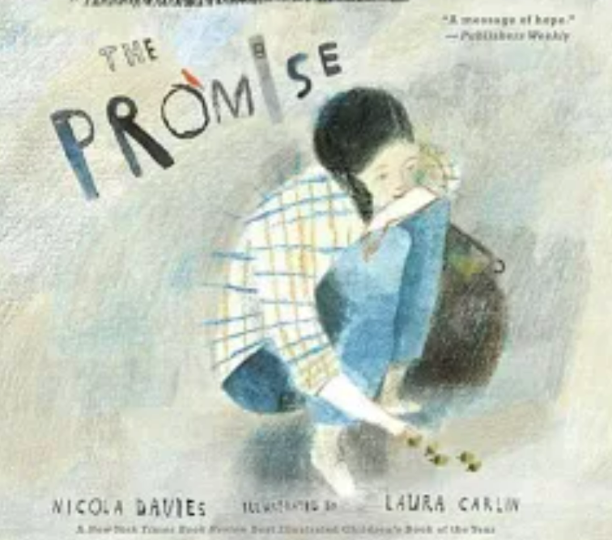 | 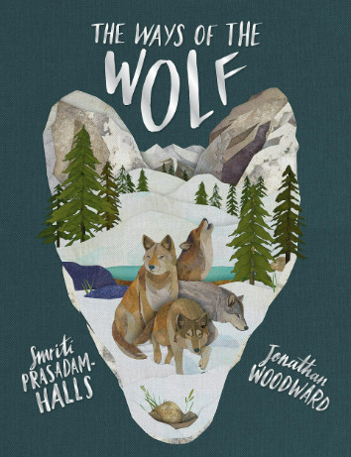 | In guided reading we are studying a variety of texts including:  Poetry  Tiger, Tiger, Burning Bright! by Fiona Waters  Non-Fiction  Coming to England by Floella Benjamin  Fiction  The Goldfish Boy by Lisa Thompson | In Maths, using White Rose Maths and Classroom Secrets, we will be covering a variety of topics including:  - Multiplication and division  - Factors and multiples  - BODMAS  - Multiplying and dividing fractions  - Simplifying fractions  - Fractions of amounts | 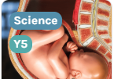  Children will learn about how animals grow and change during their life cycles, including how humans grow from babies to adults. They will explore how people change as they get older.  .
This story is about a young girl who learns how keeping a promise can change her actions and her heart. As she takes responsibility, she grows from being unkind to caring for others.  Using the Ready Steady Write scheme, we will be writing character narrative and We will produce a Non- fiction persuasive letter on how to improve our character’s city. | The Ways of the Wolf by Smriti Halls is about a wolf who learns that being kind, cooperative, and part of a pack is more important than being fierce or alone.  Using Ready steady write will write our own Documentary Narrative (Fiction) and a balanced argument (Non- fiction).

Broad and Balanced Curriculum | Geography | The children will learn how people use land for farming in different places around the world, and they will look at important natural areas.
Broad and Balanced Curriculum | Art and Design | This project teaches children about the visual qualities of line, light and shadow. They explore the work of Pablo Picasso and Rembrandt and are introduced to a range of shading techniques.
Broad and Balanced Curriculum | Design Technology | This project teaches children about pneumatic systems. They experiment with pneumatics before designing, making and evaluating a pneumatic machine that performs a useful function.
Broad and Balanced Curriculum | Physical Education | We are learning how to play netball in PE. We practise throwing, catching, and passing the ball. We work as a team, follow the rules, and try our best while having fun.
Broad and Balanced Curriculum | Computing | In computing, we will be looking at data bases and how to collect and organise data visually.
Broad and Balanced Curriculum | Music | In music, we will be doing creative composition based on Disco Fever music.
Broad and Balanced Curriculum | French | We will resume French in Spring 2.
Broad and Balanced Curriculum | RE | In RE we will be looking at How and Why we celebrate The Eucharist. We will also look at Who was Jesus and Who is he to us?

Core Value | Trust
Delivering our Capital Culture | - Cinderella whole school pantomime  - Social Brokers and the Liverpool School of Tropical Medicine
Whole School SMSC | - Social Brokers will work with UKS2 weekly to learn more about the world around us  - Ciara and the Peace Collective are working with Archer class to develop our understanding of community, actions and consequences and importance of celebrating culture.  - Miliary school, work with an alternating group of children every Tuesday to develop their leadership skills.  - MMA with Shaun happens on a Thursday, where select children work on confidence, resilience and mindfulness.
Whole-School Mental Health Focus Theme for the Half-Term | - The term in PSHE our topics are Dreams and Goals and Healthy Me. We will be shaping our aspirations and finding achievable steps to get there. We will also look at how to ensure we are healthy both mentally and physically.

