Year 2
Core Curriculum
English
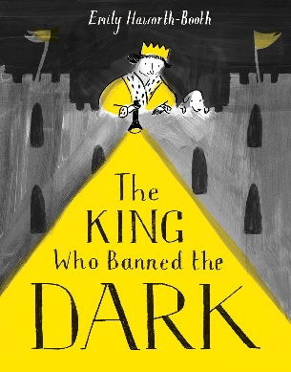 | 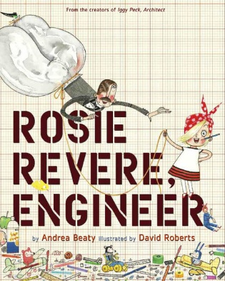
Reading and Writing  In our upcoming English unit, the children will explore the story of a king who banned darkness from his kingdom. They will develop their reading skills by making predictions, discussing characters, and learning new vocabulary. In writing, the children will describe settings, retell parts of the story, and create their own ideas. This unit will build creativity, comprehension, and confidence in both reading and writing. | Reading and Writing  In the second summer term the children will explore the story Rosie Revere, Engineer. They will develop their reading skills by discussing the characters, making predictions, and learning new vocabulary. In writing, the children will describe inventions, retell parts of the story, and share their own creative ideas. This unit encourages creativity, resilience, and confidence in both reading and writing.
Maths | Science
- Money  - Fractions  - Time  - Mass, Capacity and Temperature  - Position and Direction | In Summer 1, we will learn about Plant Parts, this project will teach the children about wild and garden plants by exploring the local environment. They will identify and describe the basic parts of plants and observe how they change over time. In the second summer term, the children will learn about animals, including fish, amphibians, reptiles, birds, mammals and invertebrates. They will identify and describe their common structures, diets, and how animals should be cared for.

Broad and Balanced Curriculum | History | This project will teach the children about their own school and locality, both today and in the past. They will compare schooling in the Victorian era to their experiences today.
Broad and Balanced Curriculum | Art and Design | This project teaches children about artwork depicting streets and buildings and focuses on the work of the American pop artist, James Rizzi. They will create a 3-D mural based on Rizzi's work.
Broad and Balanced Curriculum | Design Technology | This project teaches children about sources of food and the preparatory skills of peeling, tearing, slicing, chopping, mashing and grating. The children will use this knowledge and these techniques to design and make a supermarket sandwich according to specific design criteria.
Broad and Balanced Curriculum | Physical Education | In the first summer term, the children will develop their athletics skills, such as running at different speeds, jumping and throwing. They will use all these skills during Sports Day. In summer 2, the children will learn the skills to play striking and fielding games.
Broad and Balanced Curriculum | Computing | During the digital writing unit, the children will learn how to type on a keyboard and begin using tools to change the look of their writing, and then they will consider the differences between using a computer and writing on paper to create text. In the Programming animations unit, the children will use on-screen programming through ScratchJr.
Broad and Balanced Curriculum | Music | We will continue to follow the Charanga music scheme to learn how to sing a range of songs and play them on the glockenspiel.
Broad and Balanced Curriculum | RE | During the Baptism unit, the children will encounter the concept of God through the promises and symbols of baptism. In Summer 2, we will focus on exploring one of the most well-known epic stories of the Old Testament. The children will be able to talk about the actions and feelings of the characters and relate them to their own experiences.

Core Value | Courage and Service
Delivering our Capital Culture | We will continue to explore important knowledge and experiences that help them understand the wider world by watching Newsround daily and taking part in weekly Picture News activities during Class Worship. This learning will help to build their curiosity, confidence, and awareness of the world around them.
Whole School SMSC | We support children’s development through our SMSC (Spiritual, Moral, Social and Cultural) curriculum. This helps children to explore their values, understand right and wrong, and build positive relationships with others. We will continue to take part in discussions, themed activities, and whole-school events that celebrate different beliefs and cultures. This learning supports children in becoming respectful, thoughtful, and confident members of our school community.
Whole-School Mental Health Focus Theme for the Half-Term | Through discussions, stories, and calming strategies, the children will develop skills to support their own wellbeing and that of others. This focus helps to create a positive, supportive environment where all children feel safe, valued, and ready to learn.
Important Dates
Thursday 23rd April at 2pm - St Georges Day Class Assembly
Thursday 25th June at 9.15-10.45 – Key Stage 1 Sports Day

