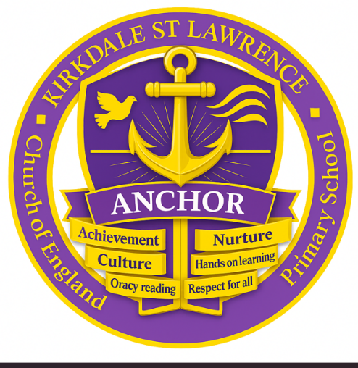

RE Curriculum 25-26
EYFS | Autumn 1 | Autumn 2 | Spring 1 | Spring 2 | Summer 1 | Summer 2
Nursery | Hope  EYFS 8: Friendship  Explore the meaning of friendship, how we make friends | Thankfulness  Christmas  EYFS 4 Christmas: How do Christians celebrate Jesus birthday? Why do Hindus light candles at Diwali? Hinduism | Courage  Stories linked to courage | Compassion  Easter  EYFS 7 Easter: Why do Christians believe Easter is all about love? | Trust  Why do Christians believe Jesus is special? | Unit S13:  Stories with Meaning from other faiths.
Reception | Hope  EYFS 1 Why am Special: Why are we all different and Special? Islam | Thankfulness  Christmas  EYFS 4 Christmas: How do Christians celebrate Jesus birthday? Why do Hindus light candles at Diwali? Hinduism | Courage  Special Places: What makes a place Holy?  Islam | Compassion  Easter  EYFS 7 Easter: Why do Christians believe Easter is all about love? | Trust  10 Prayer: What is prayer? Islam Buddhism | Unit S13:Stories with Meaning from other faiths.

KS1 | Autumn 1 | Autumn 2 | Spring 1 | Spring 2 | Summer 1 | Summer 2
Cycle A | Trust  Harvest 1.1  1.1 Harvest: How can we help those who do not have a good harvest? How do people of Jewish faith celebrate the harvest? Judaism | Thankfulness  Christmas 1.3  1.3 Christmas: Why do we give and receive gifts? Islam | Courage  1.4 Jesus: What made Jesus special? | Compassion  Easter 1.5  1.5 Easter: What do you think is the most important part of the Easter story? | Trust  1.7 Baptism: Why is baptism special? How do people of world faiths welcome new babies?  Islam | Unit S13:  Stories with Meaning from other faiths.
Cycle B | Trust  The Bible 2.1  2.1 The Bible: Why is the Bible such a special book? Do people of all world faiths have holy books? Islam | Thankfulness  Christmas 2.2  2.2 Christmas: Why was the birth of Jesus such good news? | Courage | Compassion  Easter 2.4  2.4 Easter: How do Symbols help us understand the Easter story? | 2.5 The Church: Why is the church a special place for Christians? Why are holy buildings important to people of faith? Islam Judaism | Unit S13:  Stories with Meaning from other faiths.

LKS2 | Autumn 1 | Autumn 2 | Spring 1 | Spring 2 | Summer 1 | Summer 2
Cycle A | Hope  Harvest 3.6  3.6 Harvest: How do people of faith say thank you to God for the harvest? How do people of faith say thank you to God at the harvest? Judaism Hinduism | Thankfulness  Christmas 3.2  3.2 Christmas. How does the presence of Jesus impact on people’s lives? | Courage  3.3: How Did/Does Jesus Change Lives?  Deepen children’s insight into the impact Jesus had/has on people’s lives | Compassion  Easter 3.4:  Is the cross a symbol of sadness or joy? | Trust  Rules for Living 3.5 Which rules should we follow?  Does everybody follow the same rules?  Buddism, Islam, Sikhism | Service  Harvest 3.6  How do people of faith say thank you to God for the harvest?
Cycle B | Hope | Thankfulness  Christmas 4.2  Why is Jesus described as the light of the world? Why is light an important symbol in World Faiths? Judaism | Courage  Jesus 4.3  Why do Christians believe Jesus us the Son of God? Why do Jewish people believe that the Sabbath/Shabbat is so important? Judaism | Compassion  Easter 4.4 A story of betrayal or trust? What do World Faiths say about forgiveness? Hinduism Islam Judaism Sikhism | Trust  The Church 4.5 The Church: Are all churches the same? Are all places of worship the same? Do people worship God in the same way? Hinduism Islam, Judaism Sikhism | Prayer 4.6 What is prayer? How do people of World Faiths Pray? Hinduism Islam, Judaism Buddhism

UKS2 | Autumn 1 | Autumn 2 | Spring 1 | Spring 2 | Summer 1 | Summer 2
Cycle A | Hope  The Bible 5.1: How and why do Christians read the Bible? Why are sacred texts so important to people of faith? Islam Judaism Hinduism Sikhism | Thankfulness  Christmas 5.2 How do our celebrations reflect the true meaning of Christmas? | Courage  People of Faith 6.7 People of faith: how does having faith affect people’s lives? How does having faith affect people’s lives? Buddhism Hinduism Islam | Compassion  Easter 5.4  Why do Christians believe that Easter is a celebration of victory? | Trust  Loss, Death and Christian Hope 5.6  Is death an ending or a beginning? How do people of World Faiths mark the end of life? Buddhism Hinduism Islam Humanism | Unit S13:  Stories with Meaning from other faiths.
Cycle B | Hope  Life as a Journey 6.1 Is every persons journey the same? Why do people of faith make pilgrimages? Islam Hinduism Judaism Sikhism | Thankfulnes  Advent 6.2  Advent: How do Christians prepare for Christmas? | Courage  The Exodus 6.3a  The Exodus: Why is the Exodus such a significant event in Jewish and Christian history? Judaism | Compassion  Jesus 6.4(Easter): Who was Jesus? Buddhism Islam Judaism Sikhism Hinduism | Trust  God 6.6 What is the nature and character of God? Have you discovered any beliefs about God in common across different faiths? Islam Hinduism | Unit S13:  Stories with Meaning from other faiths.

The suggested number of hours included in the syllabus contents list below for Voluntary Controlled Church Schools and Community Schools equates to 50% + curriculum time for the study of Christianity with the rest for the study of World Faiths/Views.
Pupils to experience a progressive study of Christianity and two major World Faiths at KS1 and that this study continues into KS2 with the addition of one more World Faith. Where appropriate pupils will also encounter other faiths and views but not in depth. This will mean that by the end of their time at Primary school pupils will have good knowledge and understanding of Christianity and three major World Faiths and will have encountered aspects of all major World Faiths where appropriate.

Key Stage | 1 | 2 | 3 | Others
EYFS | Islam | Judaism |  | Buddhism Sikhism
KS1 | Islam | Judaism | Buddism | Sikhism, Humasism
KS2 | Islam | Judaism | Buddism | Hinduism  Sikhism  Humanism

Key
Purple | School value
Black | Compulsory units
Green | Compulsory word faith in depth
Red | Optional world faith (touch on)
Blue | Chosen Unit

