Whole School Family Worship Plan
2025-2026
Date | Content | Lead Class
Wed 8th October  2.30pm | Harvest Festival Worship   | Archer
Tuesday 11th November  10.45am | Remembrance Worship   | Hewitt  (Inc UKMS)
Monday 1st December  2.30pm | Advent Worship   | Wilkinson
Wed 21st January  2.30pm | Wonderful World (rocks)   | Roscoe
Wed 11th February  9.20am | Safter Internet Day (launch)   | Chavasse
Fri 14th March  2.30pm | Mothers’ Day Worship   | Woodbine / Duncan
Fri 27th March  9.30pm | Easter Worship   | Braddock
Thursday 23rd April  2.30pm | St George’s Day Worship   | Quilliam
Wed 20th May  2.30pm | Our School; 25 Years Celebration  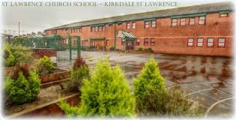 | Walker and Sheppard
Wed 15th July  10am | Nursery Graduation   | Jonas

Family Worships will have the families from that class invited.

