Autumn
Early Years Foundation Stage – Nursery (Jonas)
Prime Areas of Learning
Communication and Language | Physical Development |  | Personal, Social and Emotional Development
Listening, Attention and Understanding  We will continue to practise following simple instructions and then move onto following instructions with two parts. E.g. Get your coat and wait at the door.  Speaking  The children will be introduced to a wider range of vocabulary related to the areas in which they choose to play. | Fine Motor Skills  We have different fine motor activities set up at the beginning of each session and mark making activities based on the children’s levels of development. Children will be encouraged to use scissors to make snips in paper.  Gross Motor Skills  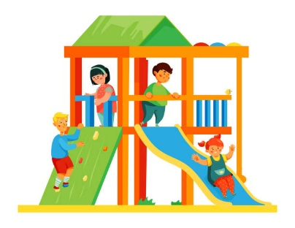  Children will continue to develop their ball skills e.g. throwing, catching, kicking and rolling. They will have access to climbing equipment and will have weekly PE lessons. Our PE lesson focus this half term is ‘balancing’. |  | The children will spend the first few weeks settling into our new routine building relationships with their peers and adults.  Self-regulation  Children will be introduced to self-regulation strategies e.g. deep breathing, five finger focus etc. Adults will model how to solve small conflicts as and when they arise.  Managing Self  We will be encouraging the children to develop independence skills and resilience. We want them to try new activities and not give up when they experience difficulties. This includes using the toilet, putting on their own coats, dressing themselves, pouring their own drinks and peeling their own fruit during snack times.  Building Relationships  Children will develop in confidence and begin to make friends. They will be taught to respect each other and build positive relationships with both their peers and adults. We will model and support them to resolve conflicts between one another in a respectful way.
Specific Areas of Learning
Literacy |  | Mathematics
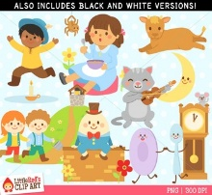  We are going to be focusing on nursery rhymes this half term. We will have a different focus each week with lots of activities related to the specific rhyme. Early phonics activities will also be linked to our rhyme of the week. The children will listen to stories daily and will have opportunities to mark make in various areas of the classroom. |  | 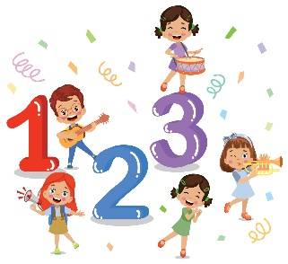  Maths this term will consist of number songs and a range of matching and sorting activities.
Understanding the World |  | Expressive Arts and Design
The children will explore materials with similar and/or different properties linked to our focus nursery rhymes. Our nursery rhymes this half term are as follows:  - Twinkle Twinkle Little Star  - Incy Wincey Spider  - The Wheels on the Bus  - 1,2,3,4,5 Once I Caught a Fish Alive  - Baa Baa Black Sheep |  | The children will:  - Explore a range of sound makers and instruments  - Take part in action songs e.g. Twinkle Star  - Explore colour and colour mixing

P.E. | We will have weekly PE lessons each Friday. We will be focusing on balancing skills.
Phonics | We are learning early phonetic skills in nursery. We play with sounds through songs, rhymes, stories and games.
R.E. | We are focusing on our school value ‘Hope’.

Core Value for Autumn term
Hope

Hope  Thankfulness  Trust  Compassion  Courage Service



