Core Curriculum
English
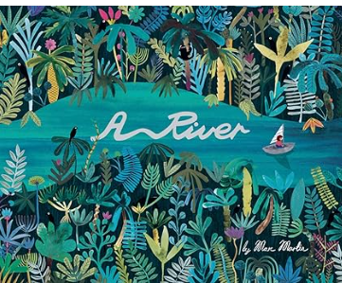 | 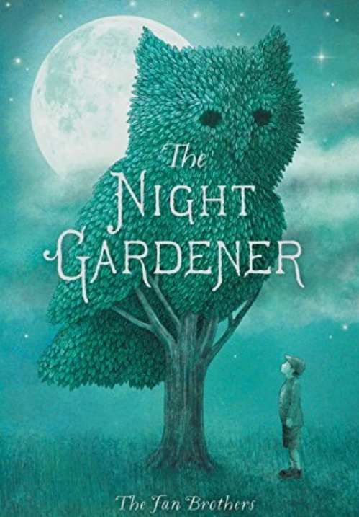
This term, Year 2 will be exploring A River by Marc Martin as part of our Ready Steady Write unit. The children will discover the journey of a river, from its source to the sea, while exploring beautiful illustrations and developing their vocabulary and descriptive writing skills. They will learn about rivers and the environments around them, use their imaginations to create settings and characters, and develop their skills in sentence construction, punctuation and storytelling. By the end of the unit, the children will use what they have learned to create their own imaginative river journey. | In Autmn 2, Year 2 will be exploring The Night Gardener by the Fan Brothers as part of our Ready Steady Write unit. The children will explore the story’s themes of kindness, community and the power of imagination, while enjoying the beautiful illustrations and mysterious events that unfold at night. They will develop their vocabulary and descriptive writing skills, learn how to create atmosphere and settings, and practise using interesting sentences, punctuation and storytelling techniques. By the end of the unit, the children will use their ideas to create their own imaginative and descriptive writing inspired by the story.
Maths | Science
- Place Value within 20 and 100  - Addition and subtraction  - Shape | We will learn the basic needs of humans for survival, including the importance of exercise, nutrition and good hygiene. They learn how human offspring grow and change over time into adulthood. We will also look at habitats and what a habitat needs to provide. The children will explore local habitats to identify and name living things and begin to understand how they depend on one another for food and shelter.

Broad and Balanced Curriculum | Geography | This topic teaches children about atlases, maps and cardinal compass points. They learn about the characteristics of the four countries of the United Kingdom and find out why there are hot, temperate and cold places around the world.
Broad and Balanced Curriculum | History | This project teaches children about historically significant people who have had a major impact on the world. They will learn to use timelines, stories and historical sources to find out about the people featured and use historical models to explore their significance.
Broad and Balanced Curriculum | Art and Design | The children will learn about basic colour theory by studying the colour wheel and colour mixing. It includes an exploration of primary and secondary colours and how artists use colour in their artwork.
Broad and Balanced Curriculum | Design Technology | This unit teaches children about three types of mechanism: sliders, levers and linkages. They make models of each mechanism before designing and making a greetings card with a moving part.
Broad and Balanced Curriculum | Physical Education | Children will take part in gymnastics lessons taught by our specialist Coach, Coach Emma. The children will learn basic skills such as jumping, rolling, balancing and they will be taught to put these skills into a short sequence. In dance lessons the children will explore traveling actions, movements and balancing.
Broad and Balanced Curriculum | Computing | In our first topic, the children will learn how to use a keyboard, simple typing skills, basic formatting and confidence using a word processor. In autumn 2 the children will become more familiar with the different components of a computer by developing their keyboard and mouse skills, and also start to consider how to use technology responsibly.
Broad and Balanced Curriculum | Music | Using the charanga scheme, the children will understand what timbre means and identify classroom percussion instruments by listening and they will improvise musical questions and answering phrases using body percussion and percussion instrument.
Broad and Balanced Curriculum | RE | Year 2 will be exploring the Bible and the Christian celebration of Christmas through our Questful RE unit. The children will learn about the Bible as a special book for Christians and explore some of the stories and teachings it contains. They will also discover the Christmas story, thinking about the birth of Jesus and why this is an important celebration for Christians. Through stories, discussion and activities, the children will consider themes such as love, hope, giving and belonging, while developing their understanding of Christian beliefs and traditions.

Core Value | Hope
Delivering our Capital Culture | Exploring Our Local Community -Children will develop a sense of belonging by learning about their local area, discussing the people and places that make our community special and thinking about how they can contribute positively.
Whole School SMSC
  Respect and Belonging – Children will explore what it means to be a good friend, respect others and understand that everyone is unique and important.
Whole-School Mental Health Focus Theme for the Half-Term | Be Kind to Your Mind – Children will learn to recognise and talk about their feelings, develop positive relationships and explore simple strategies that help them feel calm, happy and ready to learn.

