Year 3 / 4 texts
Autumn 1 / 2

Core Text  Fiction | Example Text  Non-Fiction | Reading | Maths | Science
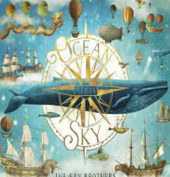 | 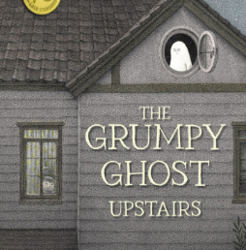 | In guided reading we are studying a variety of texts including:  Fiction;  - How to train your dragon  - Hello Universe  - The day I fell into a Fairy tale  Poetry:  - A world full of poems  - Ted Hughes collected Poems  Non- Fiction  - Explore  - An Anthology of intriguing animals   | 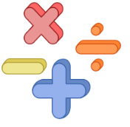  In Maths, using White Rose Maths and Classroom Secrets, we will be covering a variety of topics including:  - Place value  - Addition and subtraction  - Multiplication and division  - Area    We will be focusing heavily on our times tables! Don’t forget to log on to TT rock stars. |   Food and the Digestive System  In Science, we are looking at Food and the Digestive System.  This project teaches children about the human digestive system. They explore the main parts, starting with the mouth and teeth, identifying teeth types and their functions. They link this learning to animals' diets and construct food chains to show the flow of energy.
Children will explore Ocean Meets Sky and use it as inspiration to write their own imaginative narrative, creating a magical journey with descriptive language and exciting events.  We will be focusing on  - Sentence structure  - Expanded noun phrases  - Extended writing  - Punctuation  - Spelling, punctuation  and grammar | Children will explore ghosts and the supernatural, using their research to write an informative non-fiction text with facts, descriptions and key information.  We will be focusing on  - Sentence structure  - Researching  - Information  - Facts  - First person perspective  - Spelling, punctuation  and grammar

Broad and Balanced Curriculum | Geography – Interconnected World   | This essential skills and knowledge project teaches children about compass points and four and six-figure grid references. They learn about the tropics and the countries, climates and culture of North and South America. Children identify physical features in the United Kingdom and learn about the National Rail and canal networks. They conduct an enquiry to prove a hypothesis, gathering data from maps and surveys before drawing conclusions.
Broad and Balanced Curriculum | Art and Design – Colour Theory   | This project teaches children about colour theory by studying the colour wheel and colour mixing. It includes an exploration of tertiary colours, warm and cool colours, complementary colours and analogous colours, and how artists use colour in their artwork..
Broad and Balanced Curriculum | Design Technology –  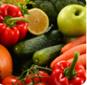 | This project teaches children about colour theory by studying the colour wheel and colour mixing. It includes an exploration of tertiary colours, warm and cool colours, complementary colours and analogous colours, and how artists use colour in their artwork.
Broad and Balanced Curriculum | Physical Education  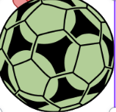 | We are developing our skills in Hand Ball. We are trying new passes such as bounce passes, shoulder and chest passes. Most importantly, we are ensuring we work ad a team.
Broad and Balanced Curriculum | Computing   | In computing, the children will be developing their essential skills. We will be learning how to create, edit, write and develop documents on Microsoft Word!
Broad and Balanced Curriculum | Music.  Create and Notate   | By the end of this unit, children will be able to:  1. Copy and improvise short melodic phrases.  2. Compose a short, structured piece using Music Explorer using a D minor scale.
Broad and Balanced Curriculum |   French | We will ask and answer questions on a range of topics. Repeat and recognise weather conditions, use verbs in the present tense, join in with an action song about the weather, listen and show understanding of sentences about the weather, listen and show understanding of multiples of 10 to 60.
Broad and Balanced Curriculum | RE   | In this unit, children explore the Christian concepts of God, Creation, the Fall, the People of God, the Incarnation, the Gospel, Salvation and the Kingdom of God. They learn how Christian beliefs and stories help people understand important values and how these values influence the choices they make.

Core Value | Hope
Delivering our Capital Culture | - Viking drop day down!  - Visits to local places of worship  - Peace Collective sessions  - Visits from a local dentist  - Learning Song from famous Liverpool Artists (The Beatles!)
Whole School SMSC | - Miliary school will work with each class delivering a 12 week course every Tuesday and develop skills such as wellbeing and fitness with a focus on the body and mind, endurance, team building, First aid and survival skills.  - MMA with Shaun happens on a Thursday, where select children work on confidence, resilience and mindfulness.  - Working with the SMILE squad wit LFC Foundation and teeth brushing  - Peace collective will be working with children to develop ways to improve our community and build strong respectful communities.
Whole-School Mental Health Focus Theme for the Half-Term | - Our Term focus for PSHE is Being Me in My World. This topic focuses on developing positive attitudes and thoughtful actions both in school and in the wider community. Children learn about different roles and responsibilities, the meaning of democracy, and how everyone can have a voice. They explore empathy by considering other people’s feelings and viewpoints, and reflect on how their behaviour impacts others. This supports pupils in becoming more responsible, respectful and active members of their class and school.

