 | Autumn 1 | Autumn 1 | Spring 1 | Spring 2 | Summer 1 | Summer 2
Keys Stage 1  (Year 1 and 2) | Being Me in My World  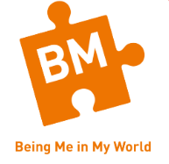 | Celebrating difference   | Dreams and Goals   | Healthy Me | Relationships  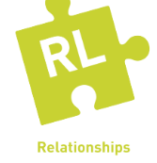 | Changing Me  
Lower Key Stage 2  (Year 3 and 4) | Being Me in My World | Celebrating difference | Dreams and Goals | Healthy Me | Relationships | Changing Me
Upper Key stage 2  (Year 5 and 6) | Being Me in My World | Celebrating difference | Dreams and Goals | Healthy Me | Relationships | Changing Me

